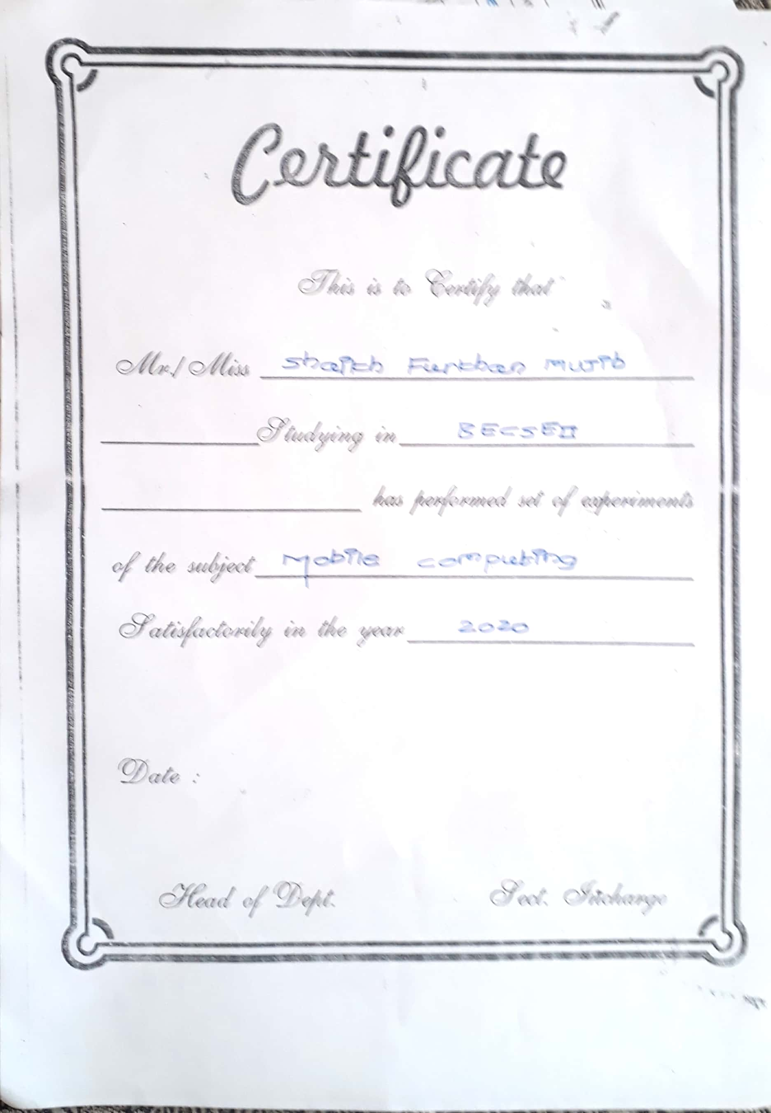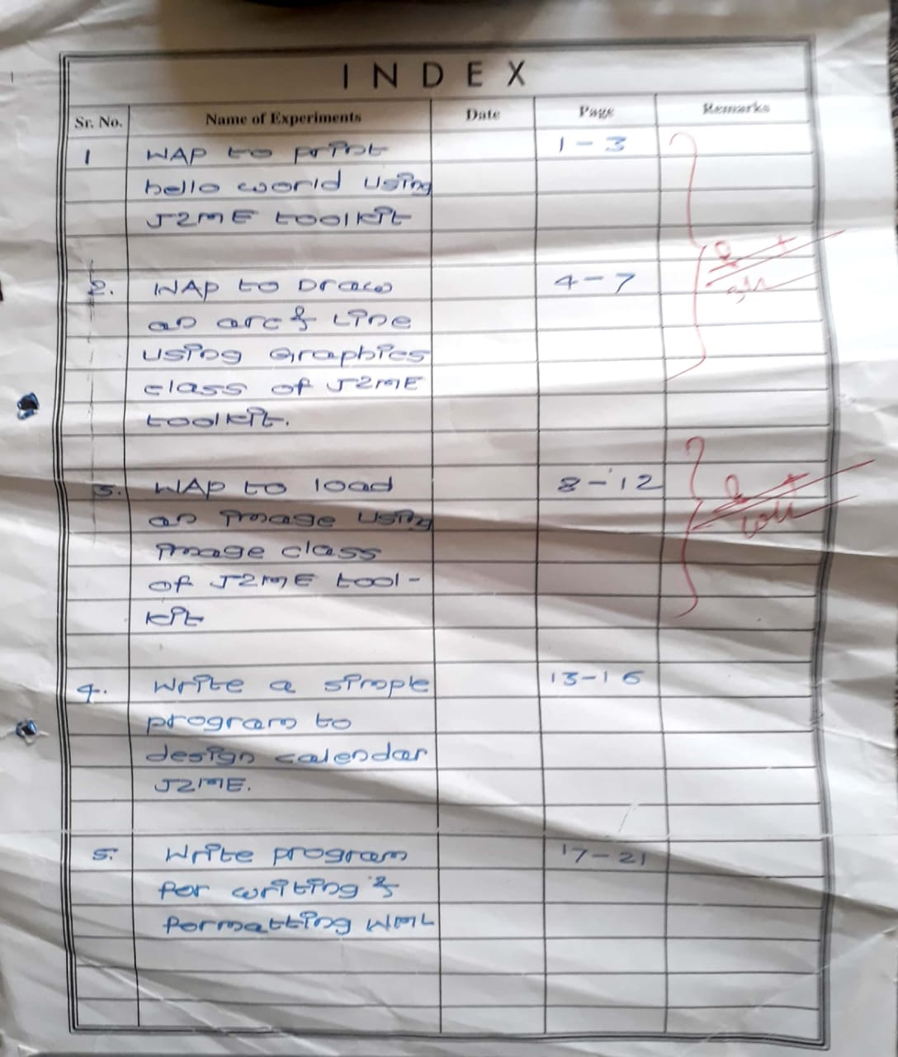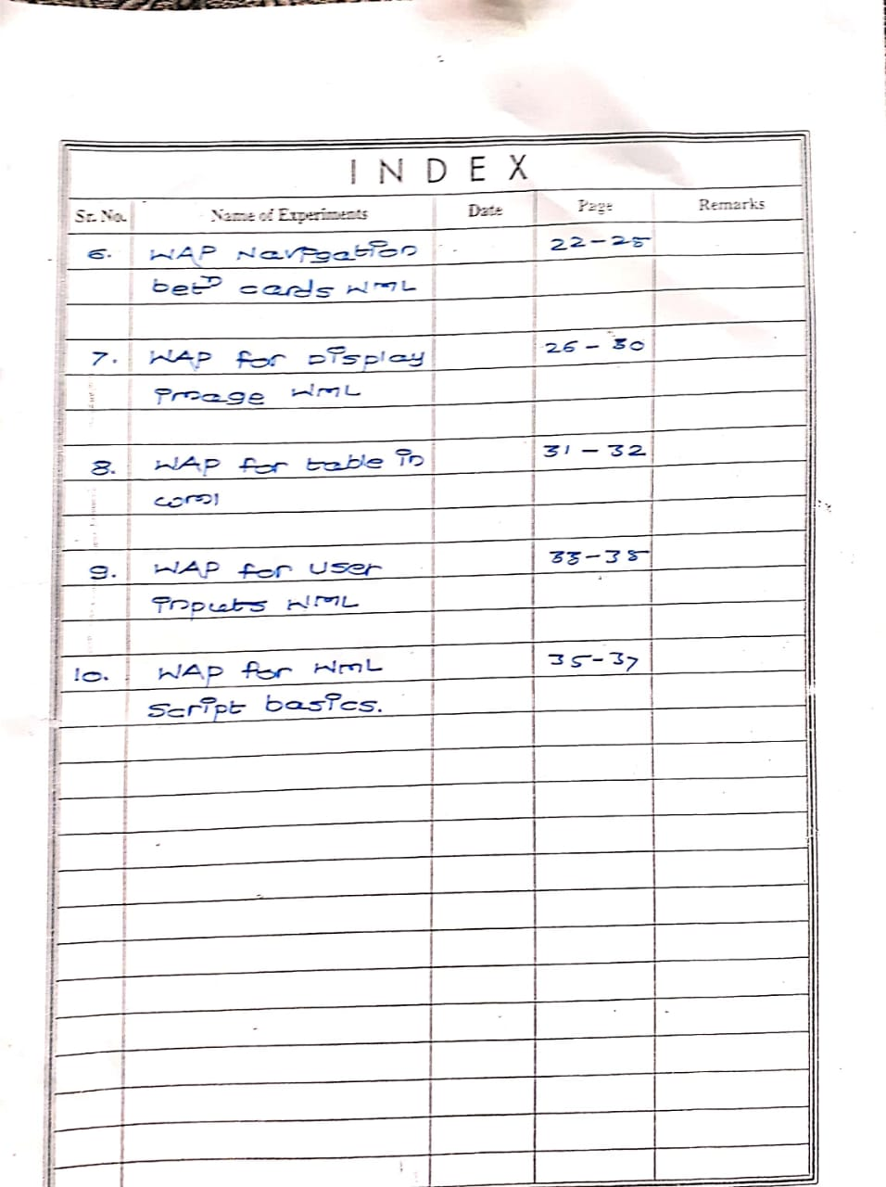

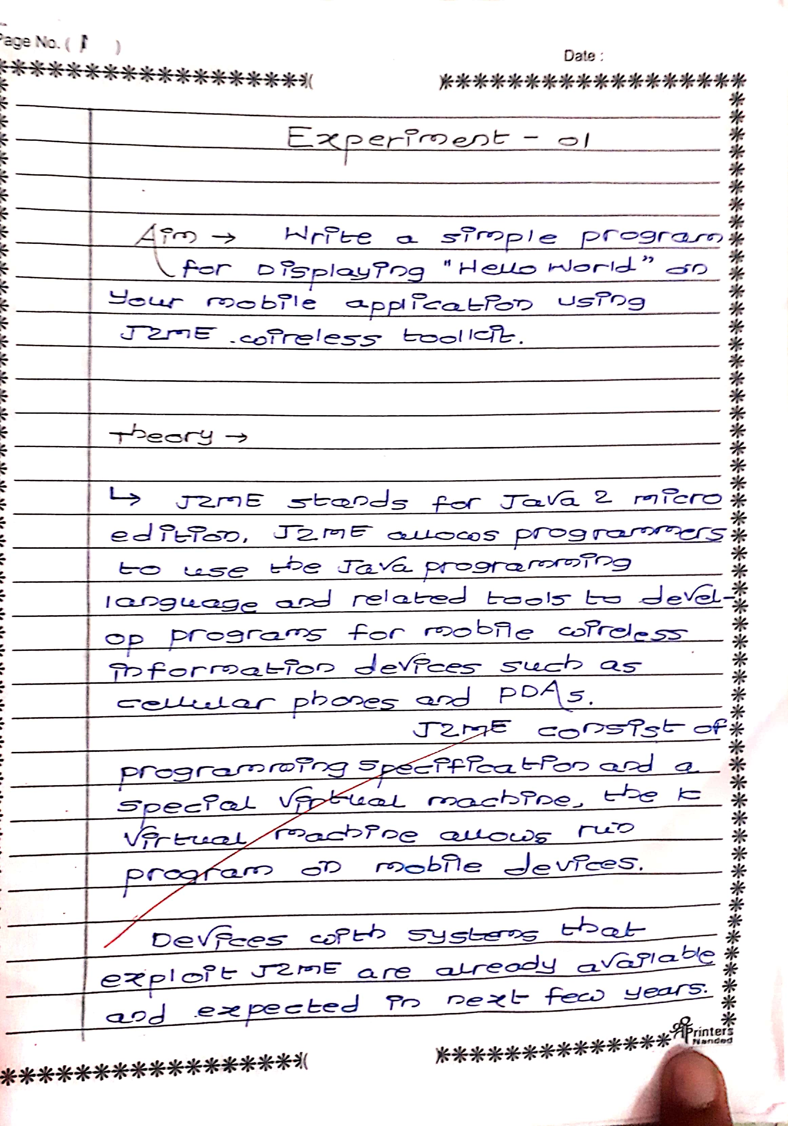

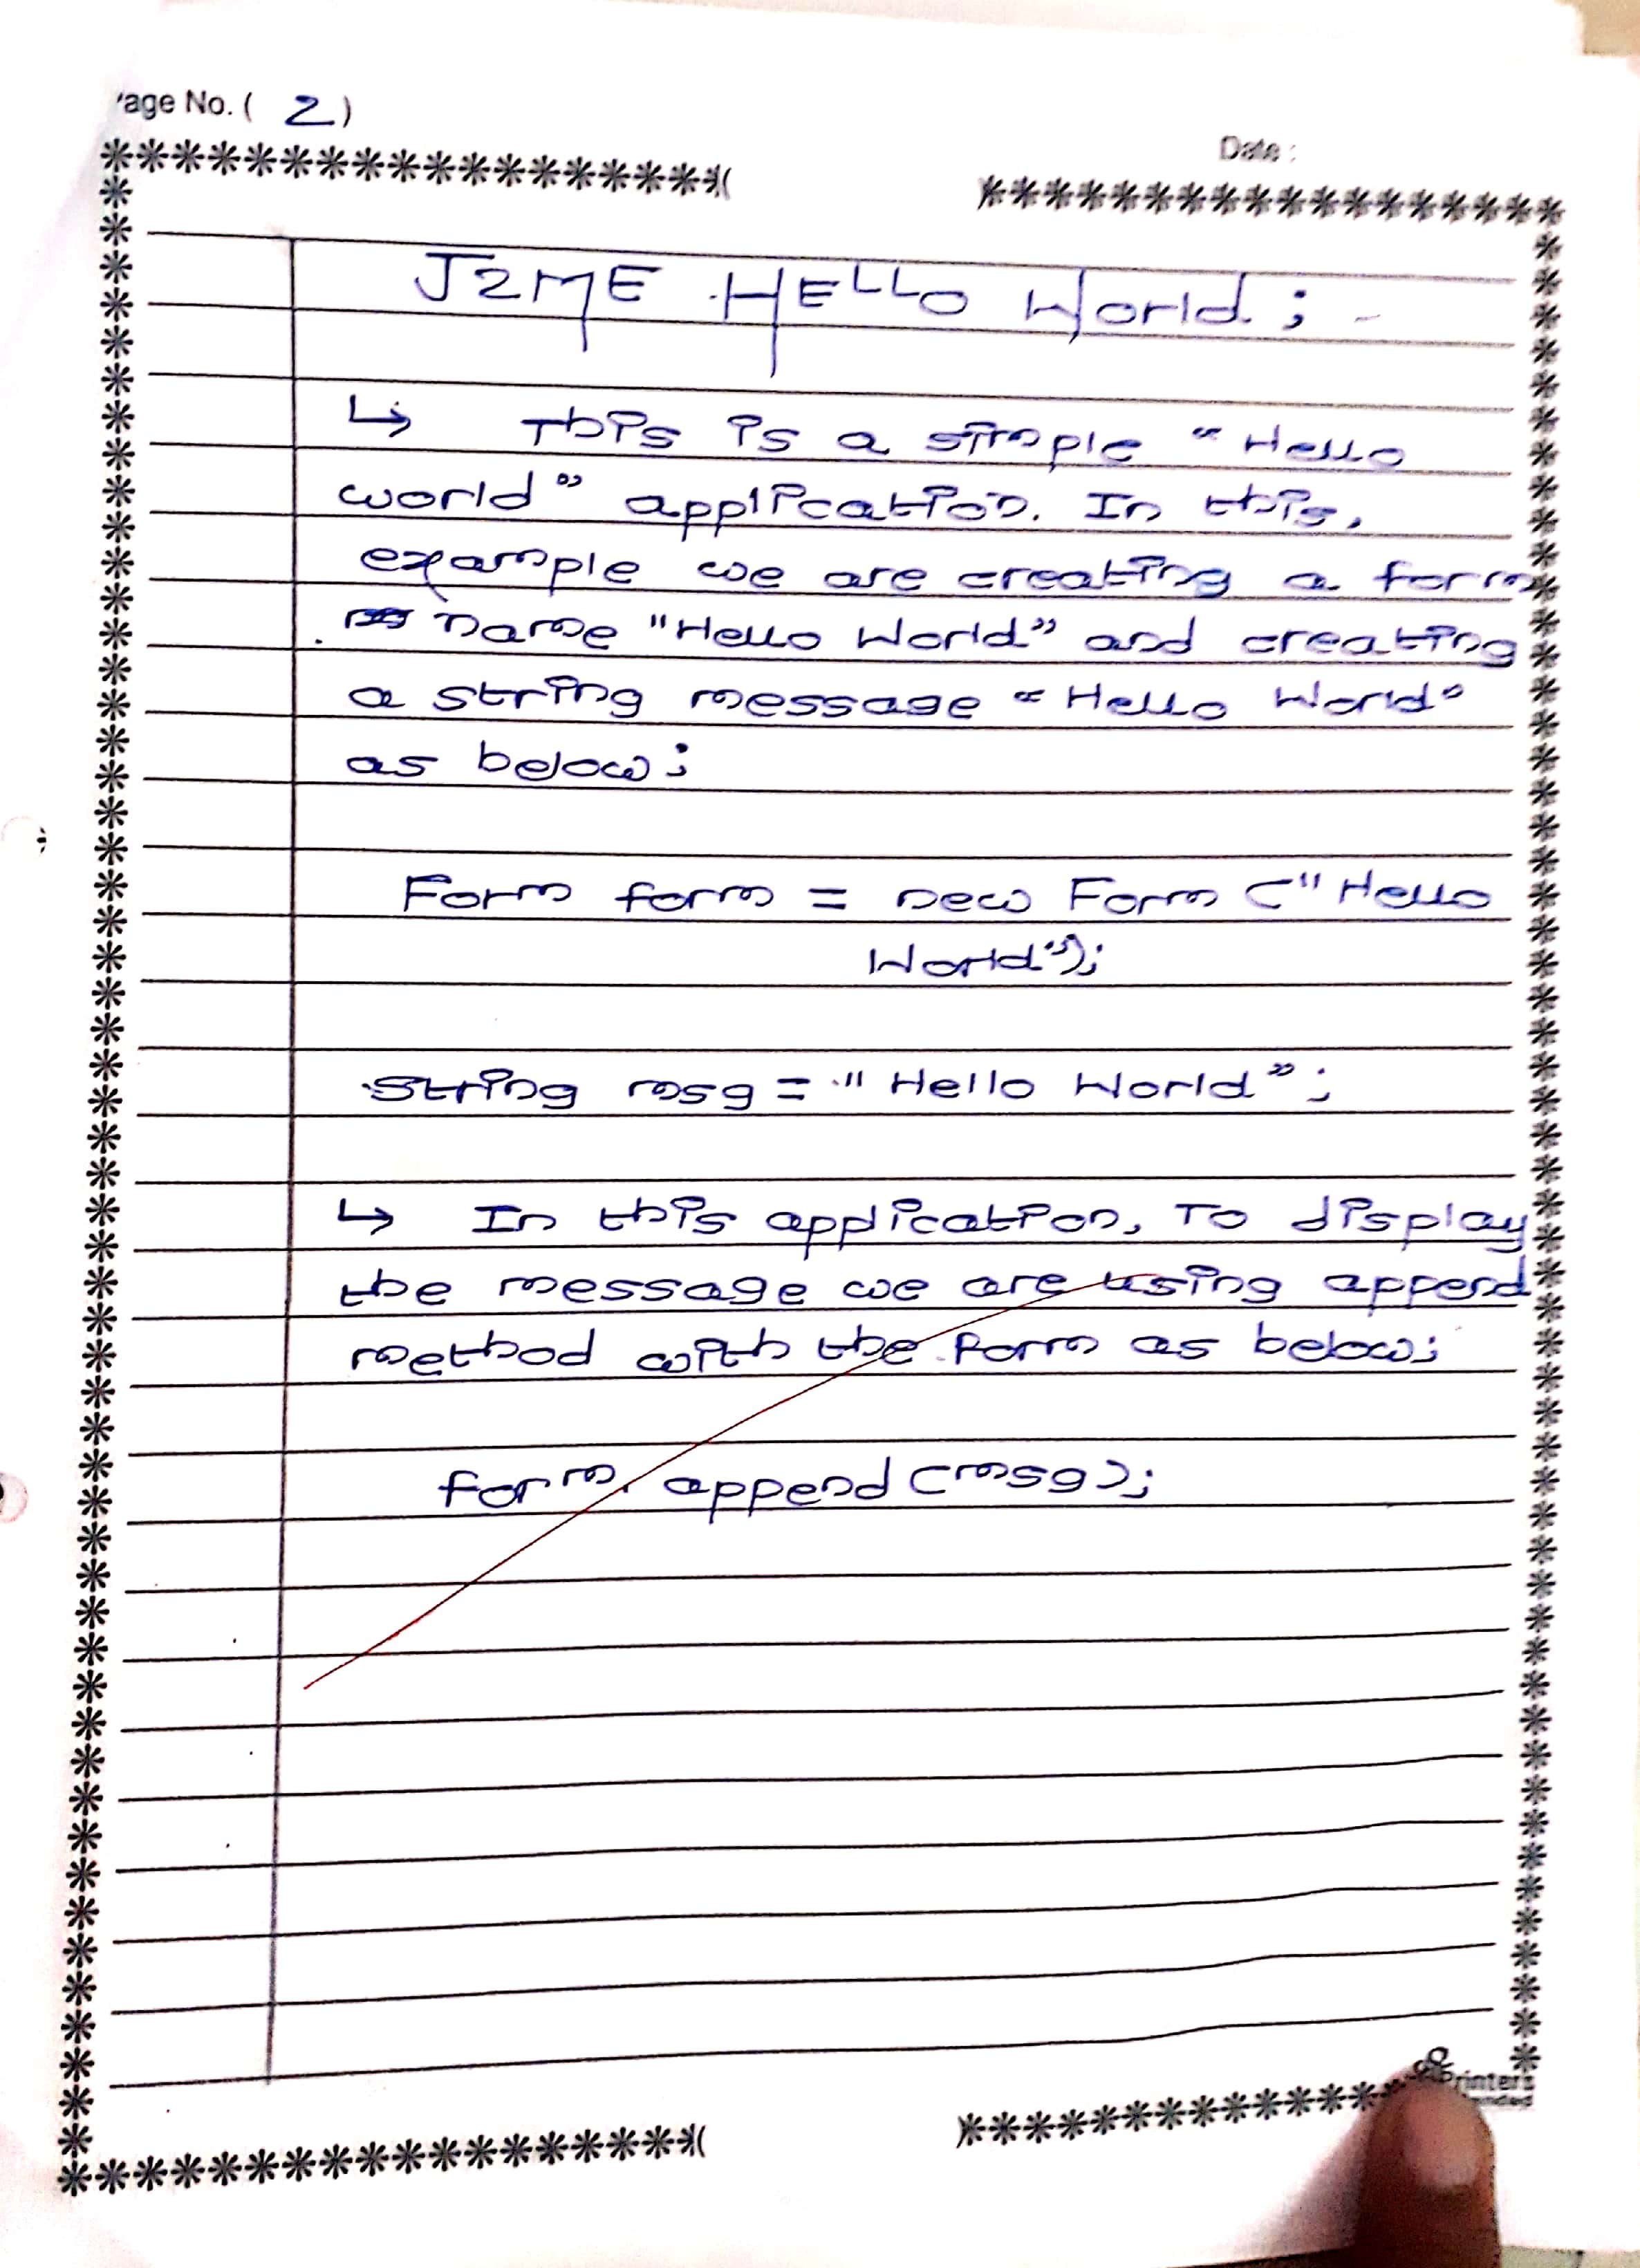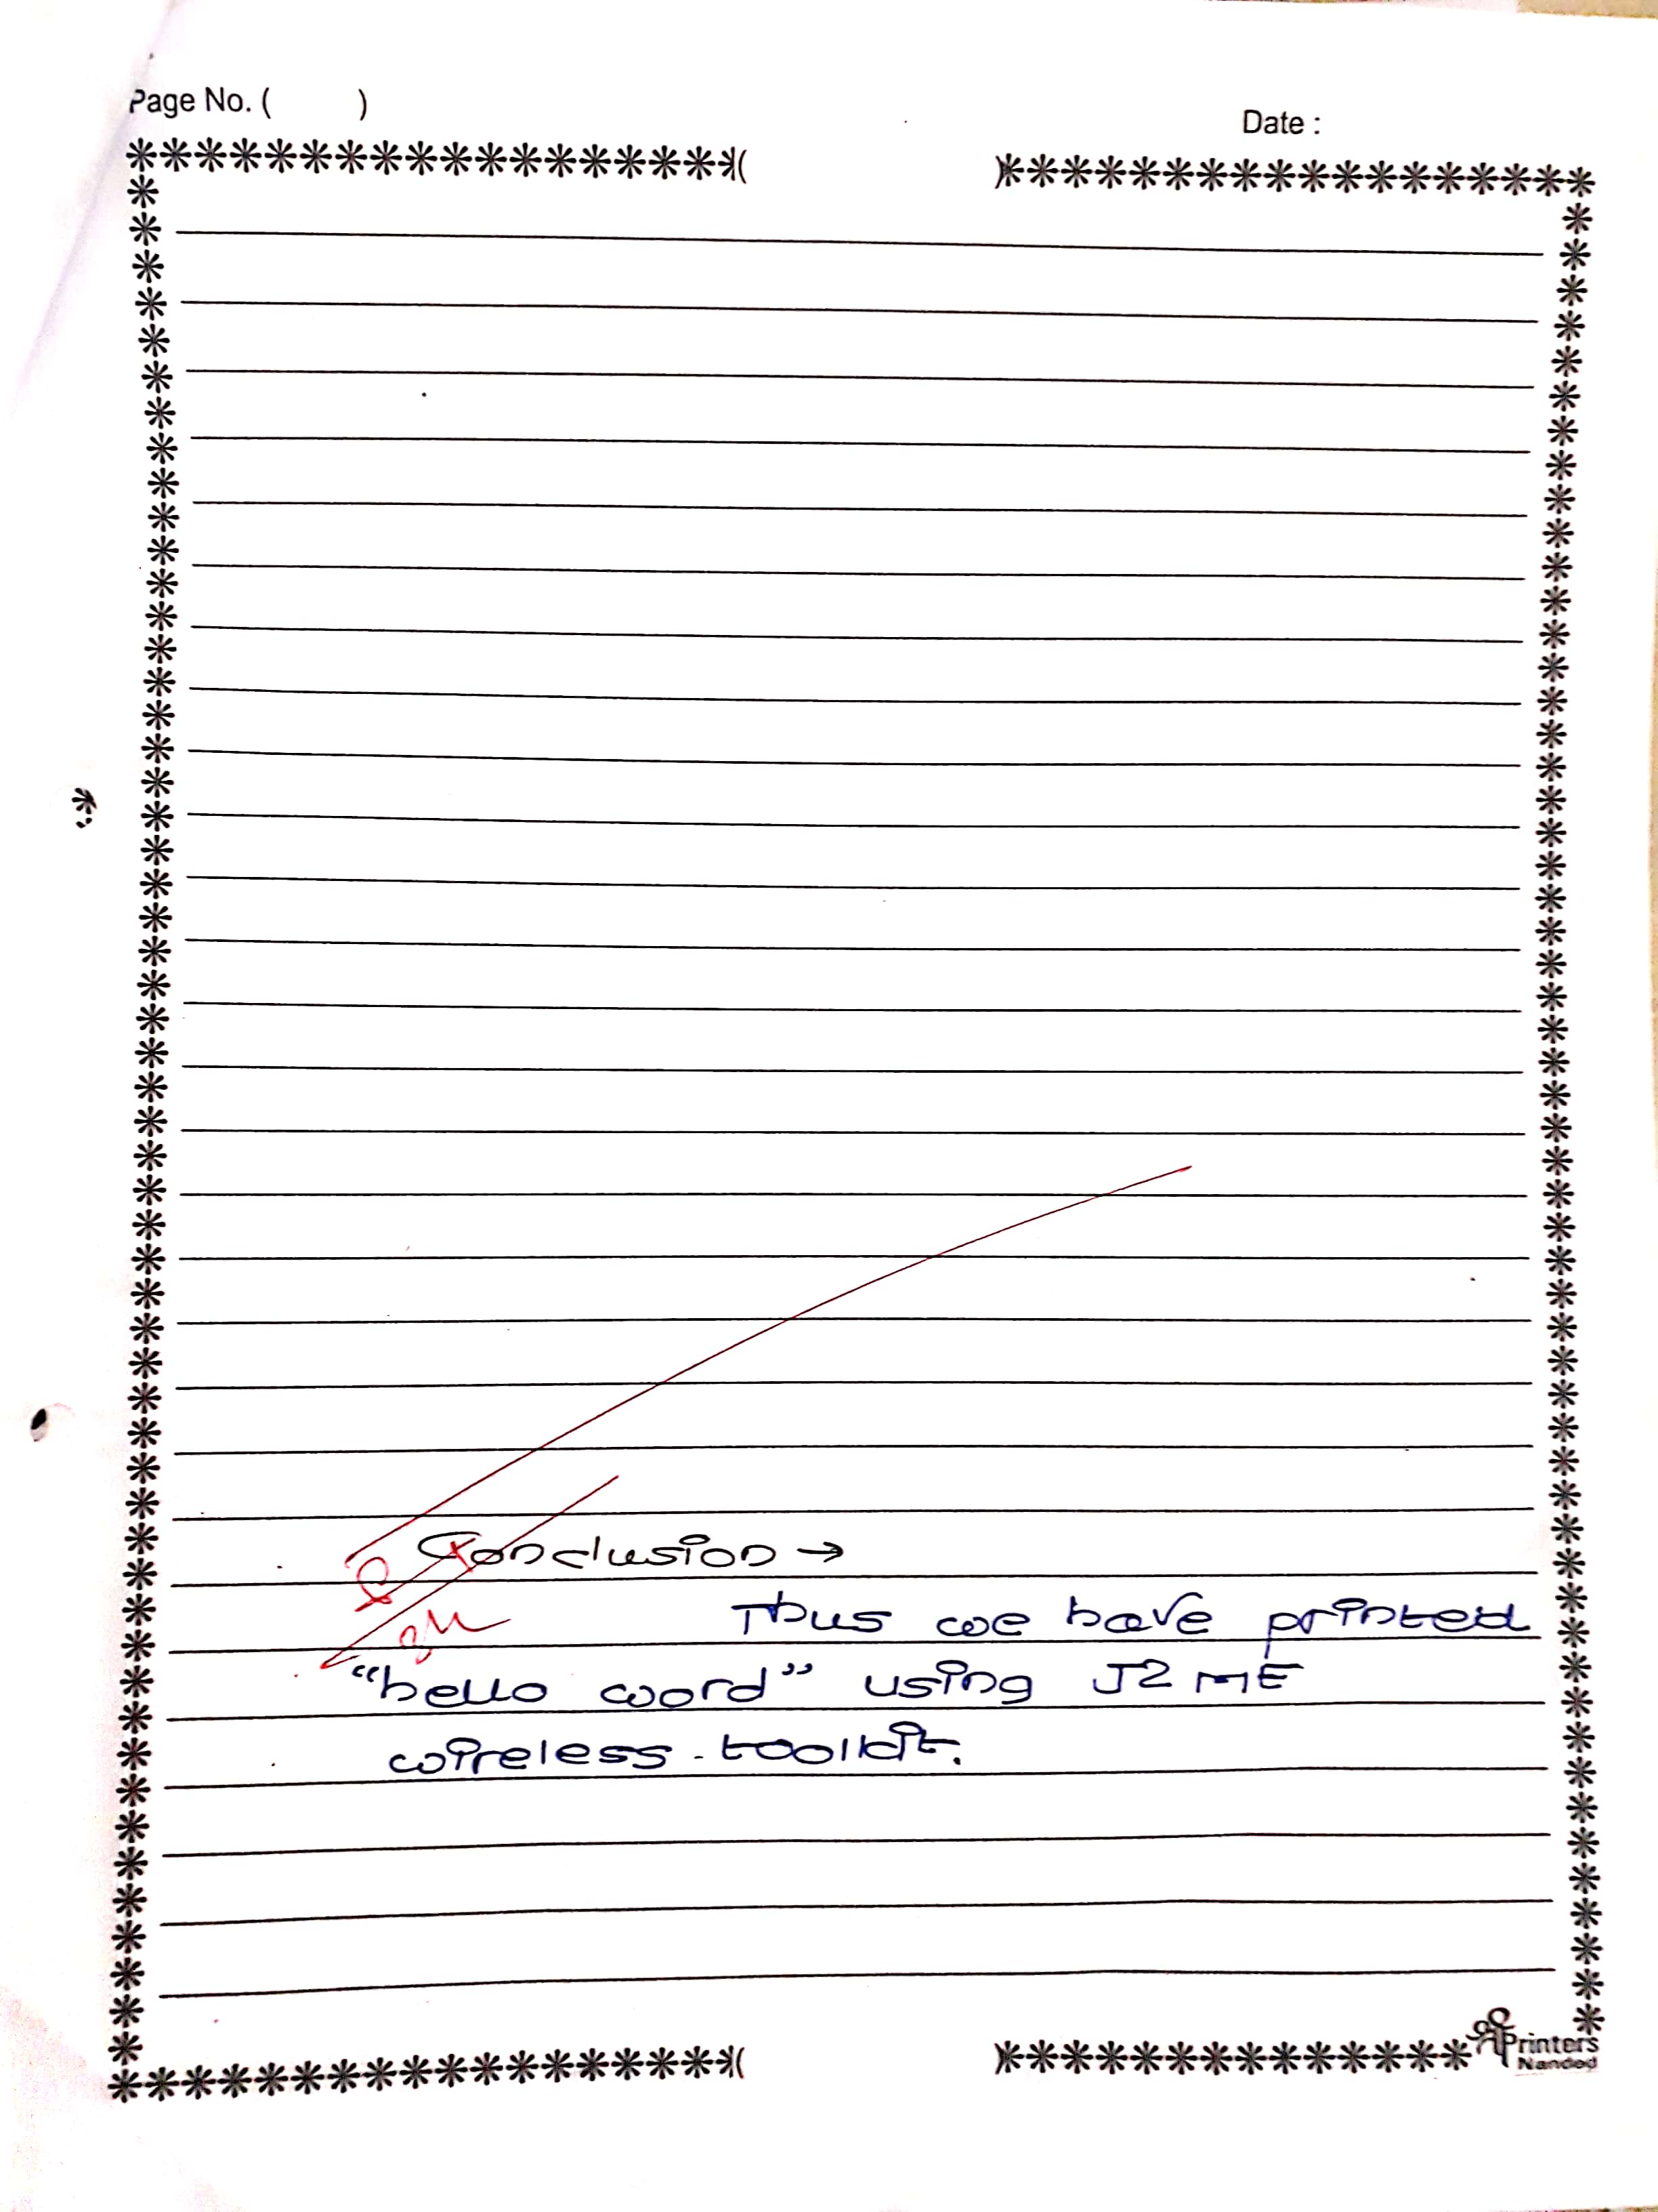

**NAME : FURKHAN MUJIBODDEN SHAIKH**

**ROLL_NO: 63**

**CLASS: BECSEII**

**AIM: WRITE A PROGRAM TO PRINT HELLO WORLD**

package helloworld;

import javax.microedition.lcdui.*;

import javax.microedition.midlet.*;

public class HelloWorld extends MIDlet{

private Form form;

private Display display;

public HelloWorld(){

super();

}

public void startApp(){

form = new Form("Hello World");

String msg = "Hello World!!!!!!!";

form.append(msg);

display = Display.getDisplay(this);

display.setCurrent(form);

}

public void pauseApp(){}

public void destroyApp(boolean unconditional){

notifyDestroyed();

}

}

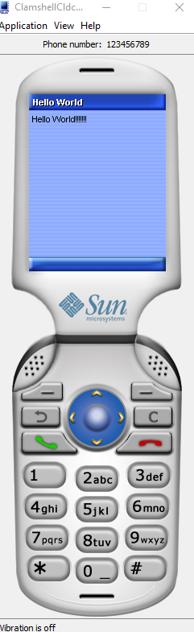

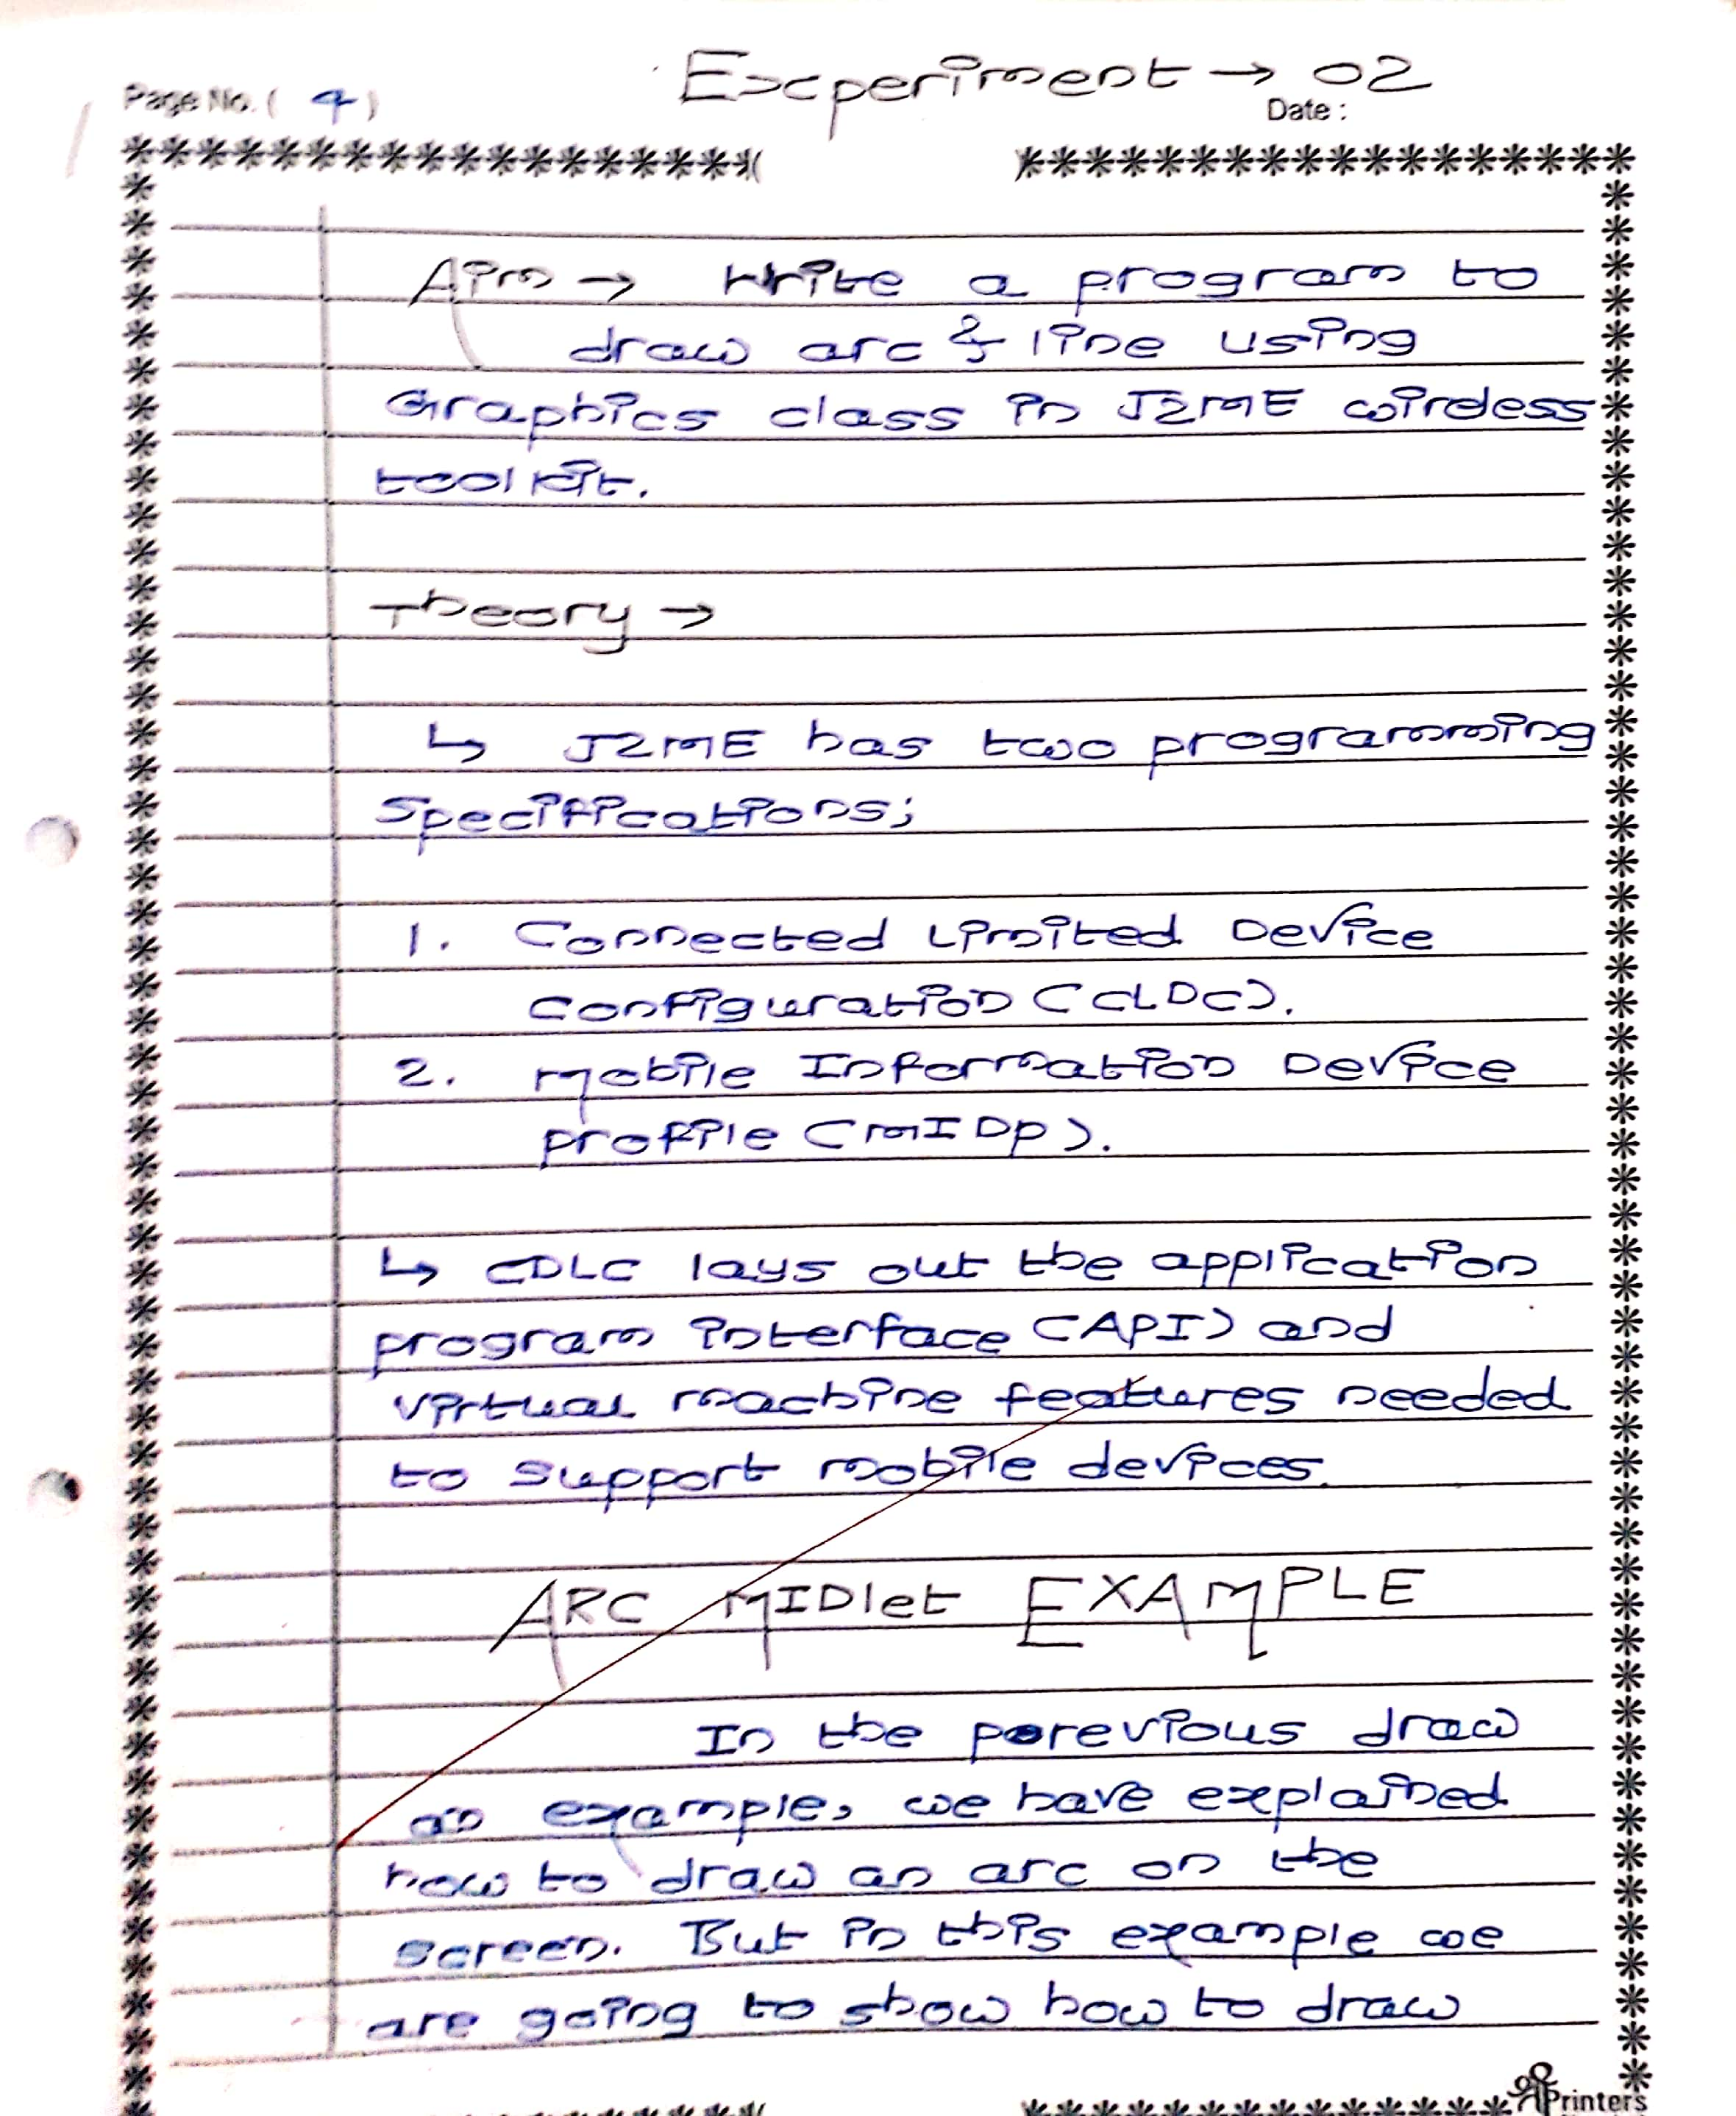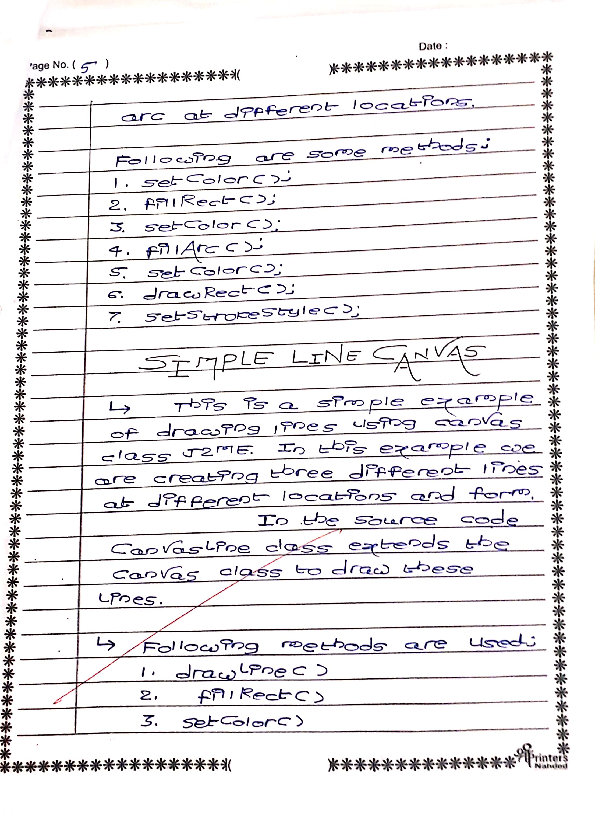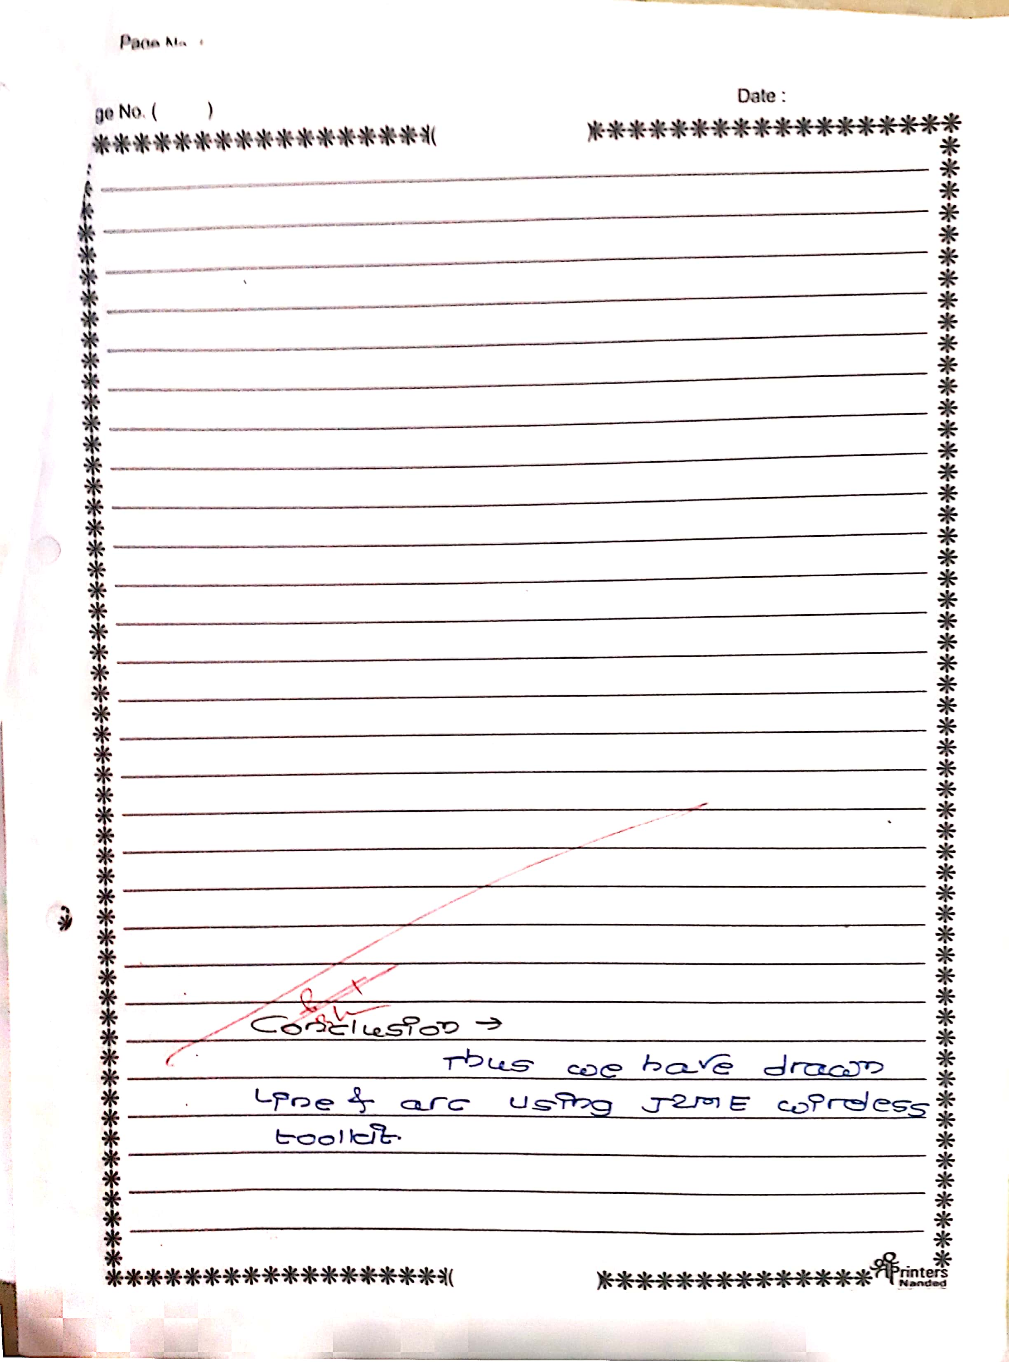

**NAME: FURKHAN SHAIKH**

**CLASS: BECSEII**

**AIM: WRITE A PROGRAM TO DISPLAY LINE, ARC**

package exp2;

import javax.microedition.midlet.*;

import javax.microedition.lcdui.*;

public class LineCanvas extends MIDlet{

private Display display;

public void startApp(){

Canvas canvas = new CanvasLine();

display = Display.getDisplay(this);

display.setCurrent(canvas);

}

public void pauseApp(){}

public void destroyApp(boolean unconditional){}

}

class CanvasLine extends Canvas {

public void paint(Graphics g) {

int width = getWidth();

int height = getHeight();

g.setColor(255, 162, 117);

g.fillRect(0, 0, width, height);

g.setColor(0, 0, 255);

g.drawLine(0, height/2, width - 1, height/2);

g.setStrokeStyle(Graphics.DOTTED);

g.setColor(0xFFFF00);

g.drawLine(0, height/4, width - 1, height/4);

g.setColor(0, 0, 255);

g.setStrokeStyle(Graphics.SOLID);

g.drawLine(0, 0, width - 1, height - 1);

g.fillArc(20, 20, 100, 100, 180, 180);

}

}

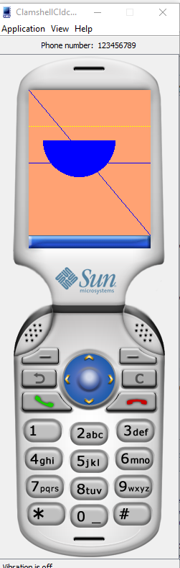

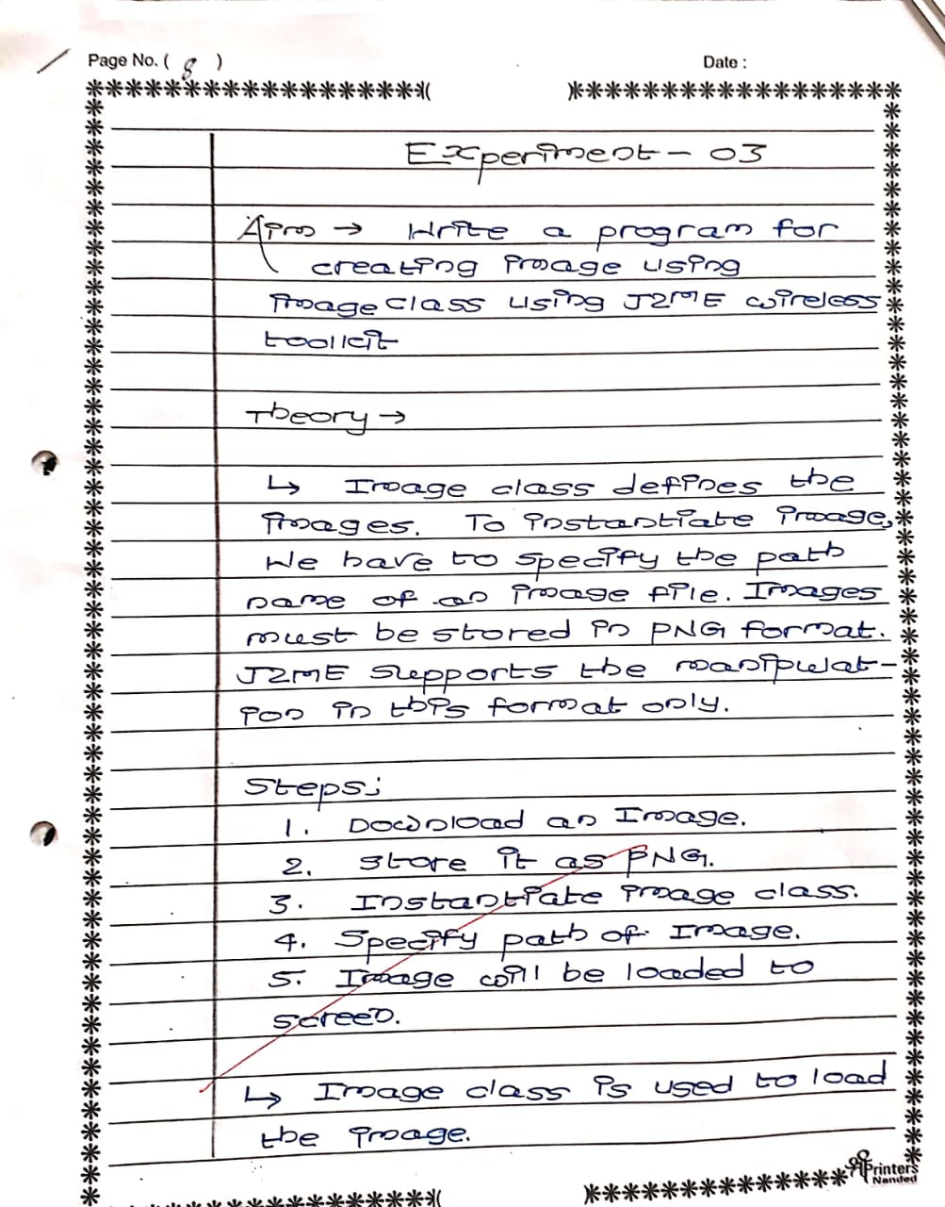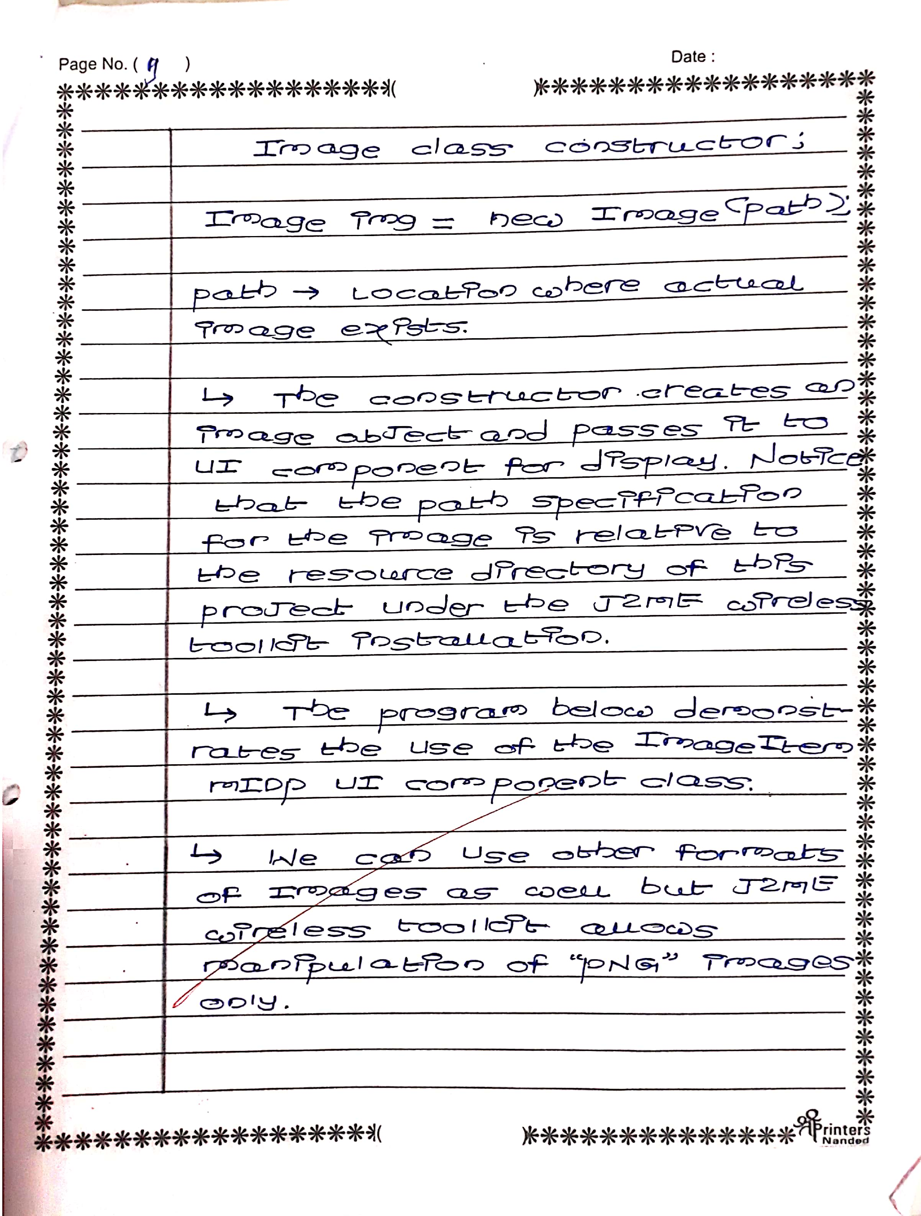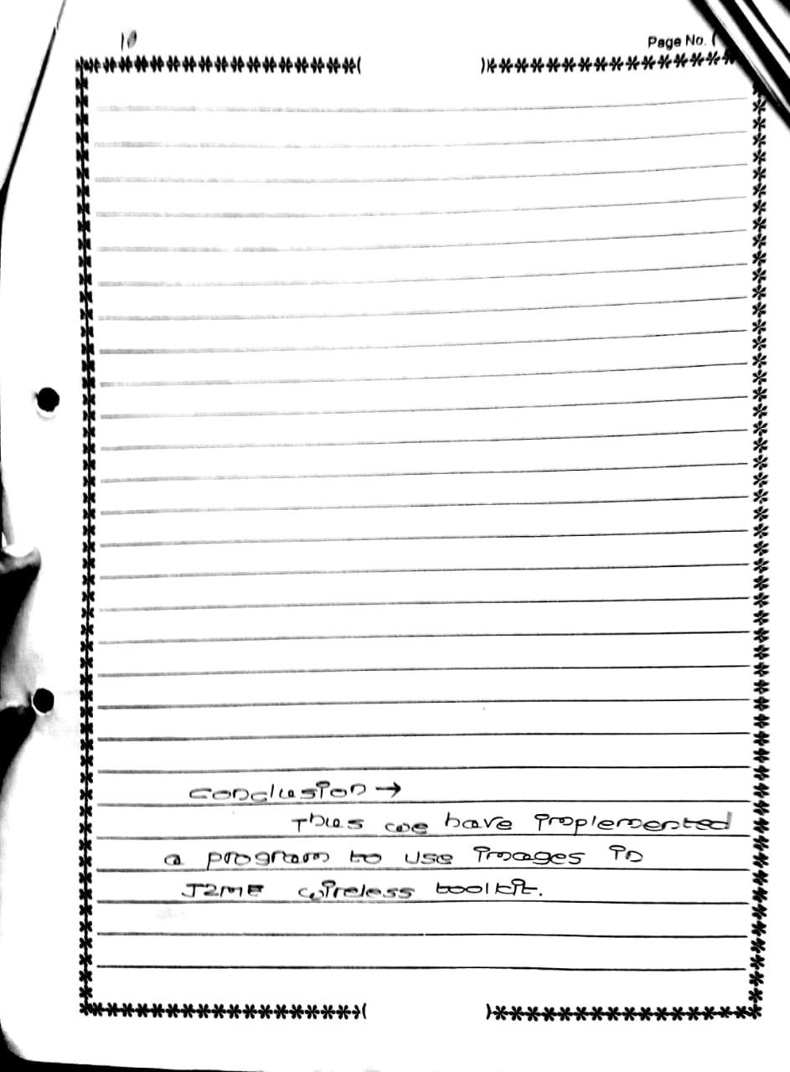

**NAME : FURKHAN SHAIKH**

**ROLL: 63**

**AIM: WAP TO DISPLAY IMAGE**

package image;

import javax.microedition.lcdui.*;

import javax.microedition.midlet.*;

public class SlideImage extends MIDlet{

private Display display;

private SimpleSlidingCanvas canvas;

public void startApp(){

canvas = new SimpleSlidingCanvas();

display = Display.getDisplay(this);

display.setCurrent(canvas);

} public void pauseApp(){}

public void destroyApp(boolean unconditional){

notifyDestroyed();

}}

class SimpleSlidingCanvas extends Canvas implements Runnable{

Image image = null;

public SimpleSlidingCanvas(){

try{

this.image = Image.createImage("/SATYAMEV.jpg");

new Thread(this).start();

}catch(Exception e){

e.printStackTrace();

}

}

public void run(){

while(true){

repaint();

try{ synchronized(this){

wait(50L);

} }catch(Exception e){ e.printStackTrace(); } } }

protected void paint(Graphics g){

g.setColor(0xffffff);

g.fillRect(0, 0, getWidth(), getHeight());

if(image != null){

g.drawImage(image, getWidth() / 2, getHeight() / 2, Graphics.HCENTER

| Graphics.VCENTER);

} else {

g.setColor(0x000000);

g.drawString("No image available", getWidth() / 2, getHeight() / 2, Graphics.HCENTER | Graphics.BASELINE);

}

}

}

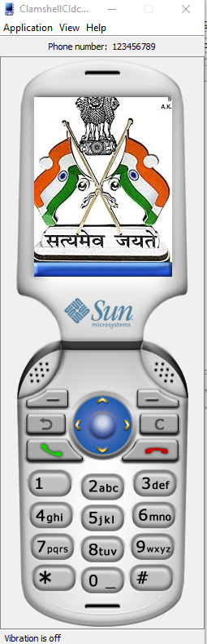

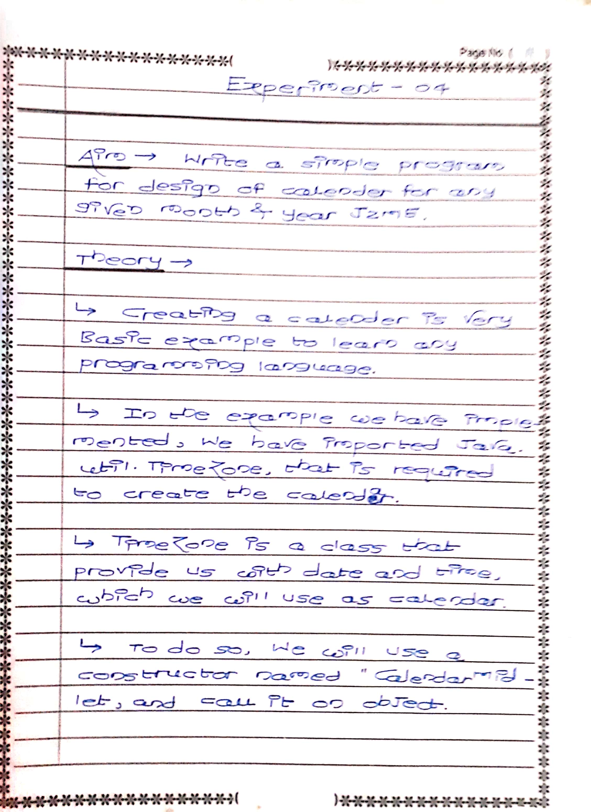

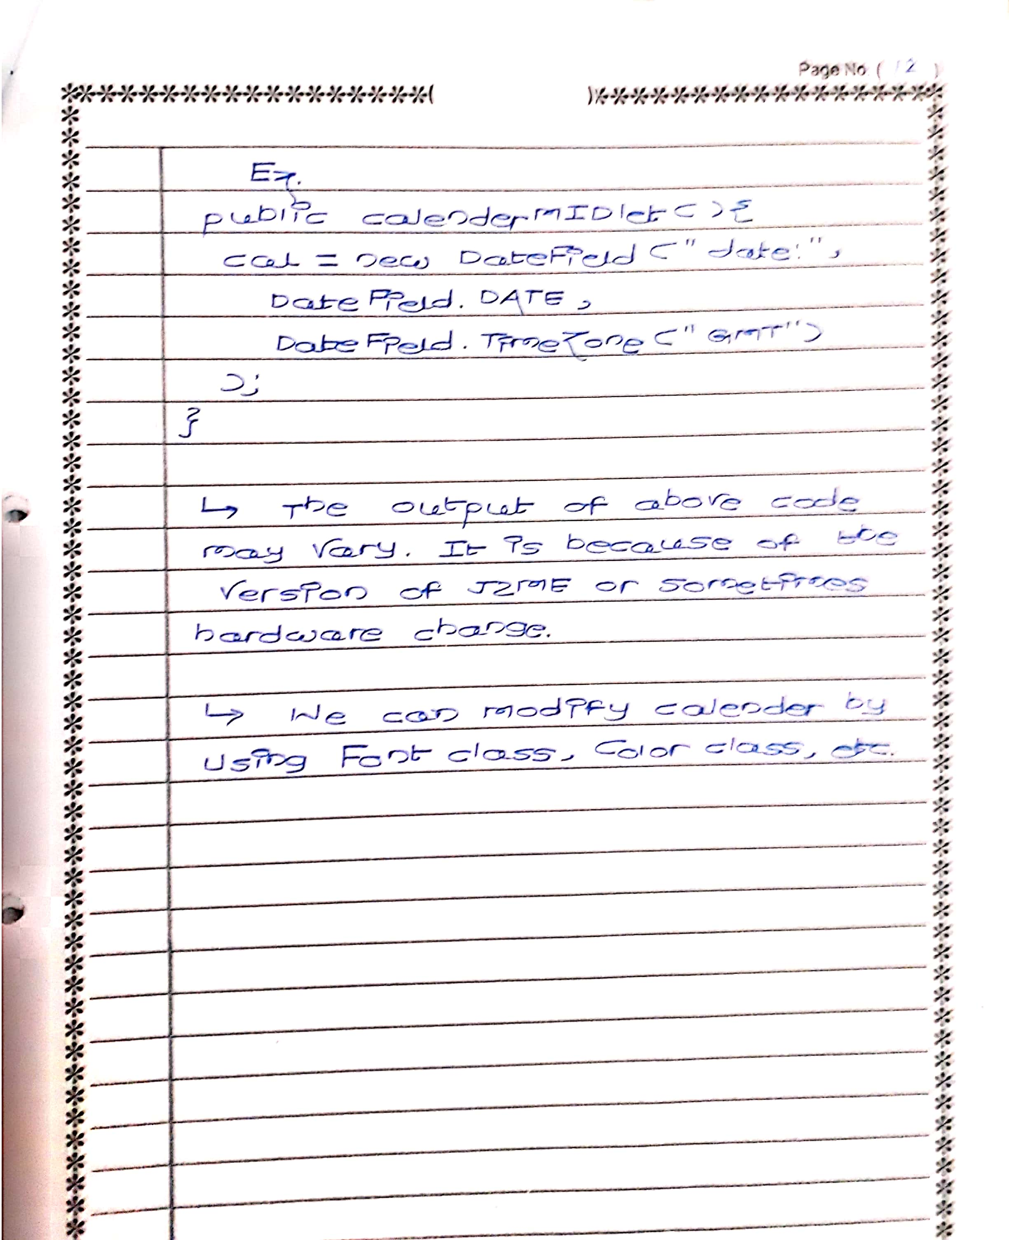

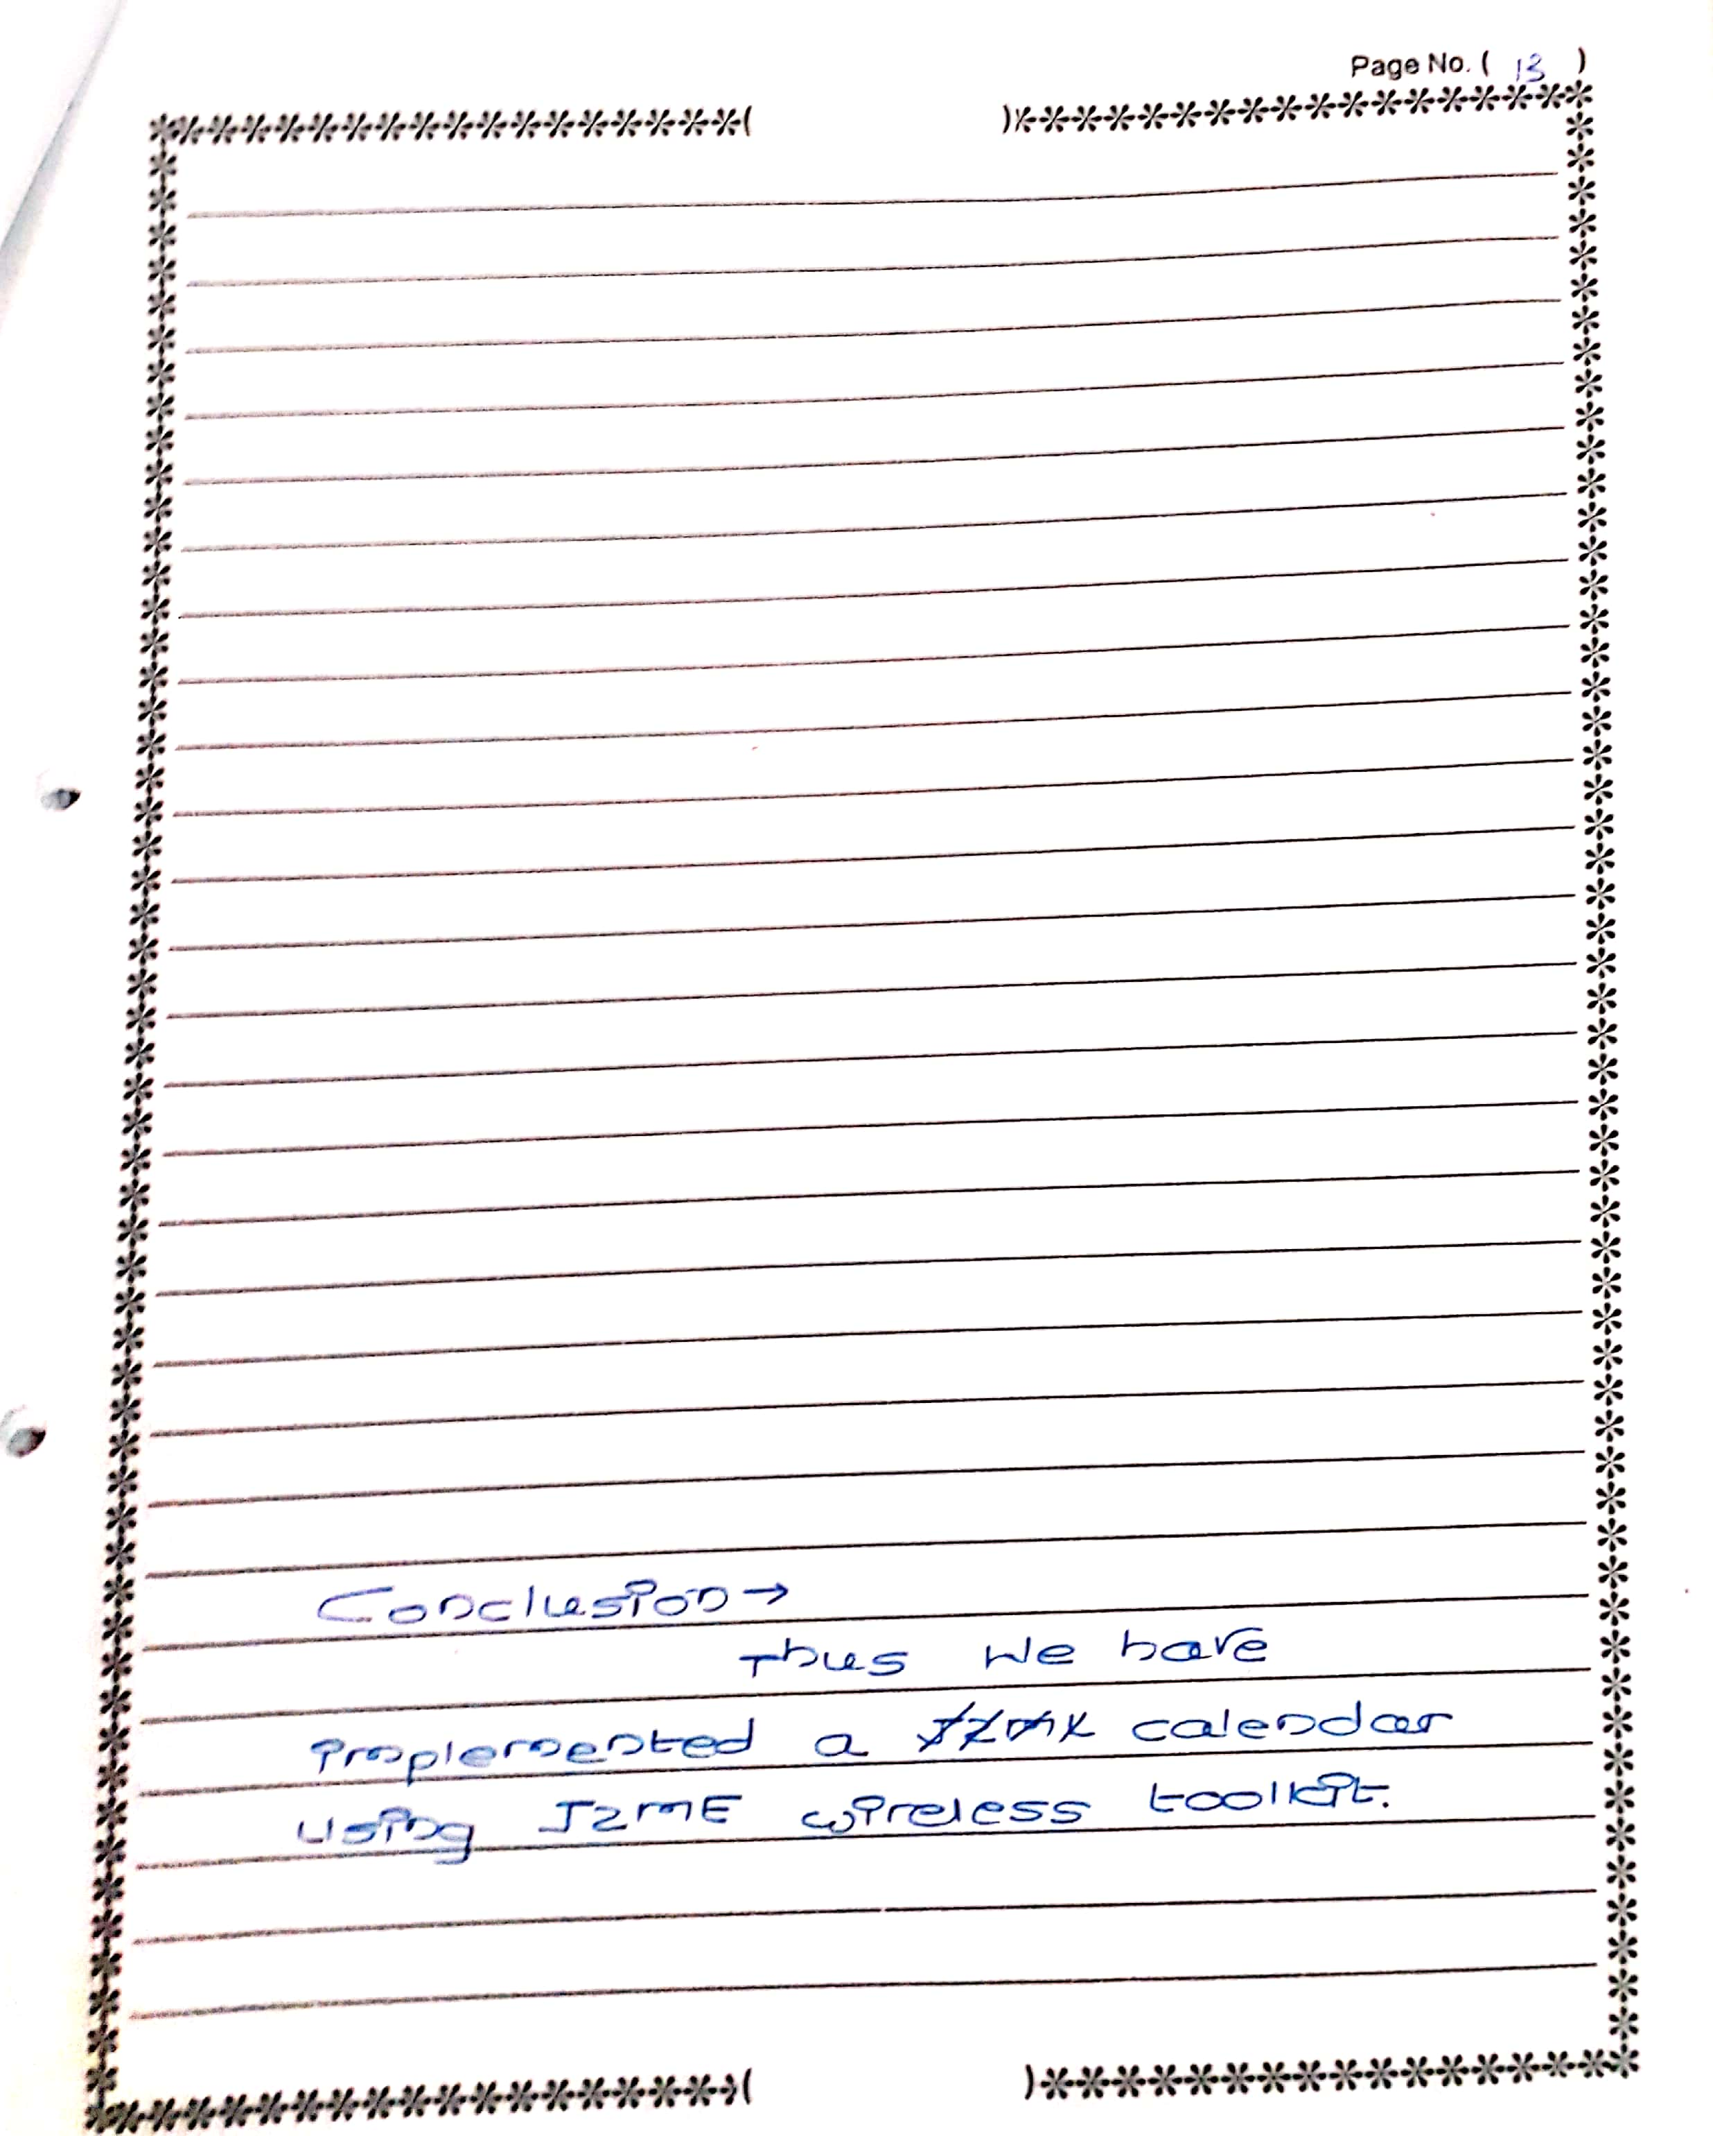

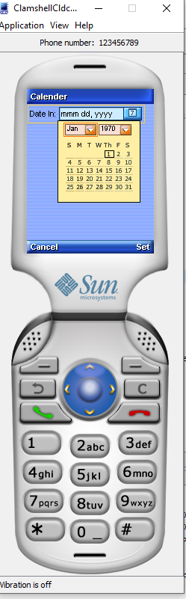

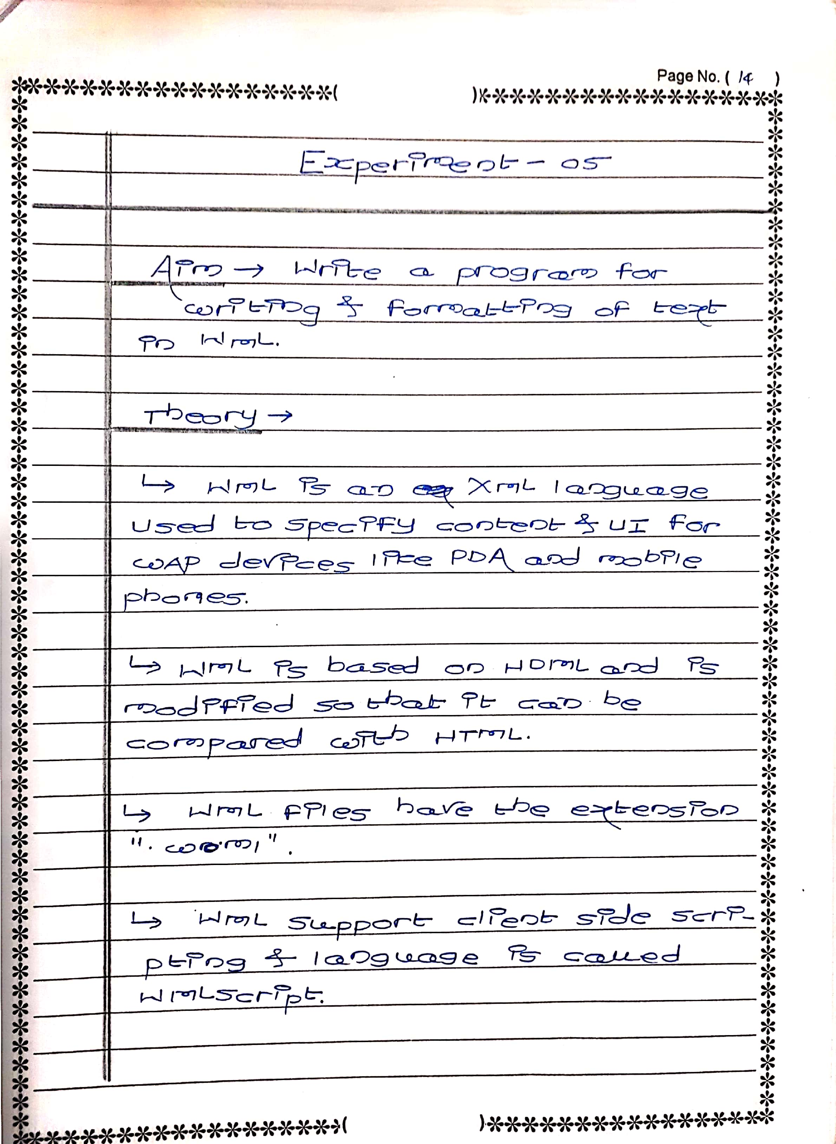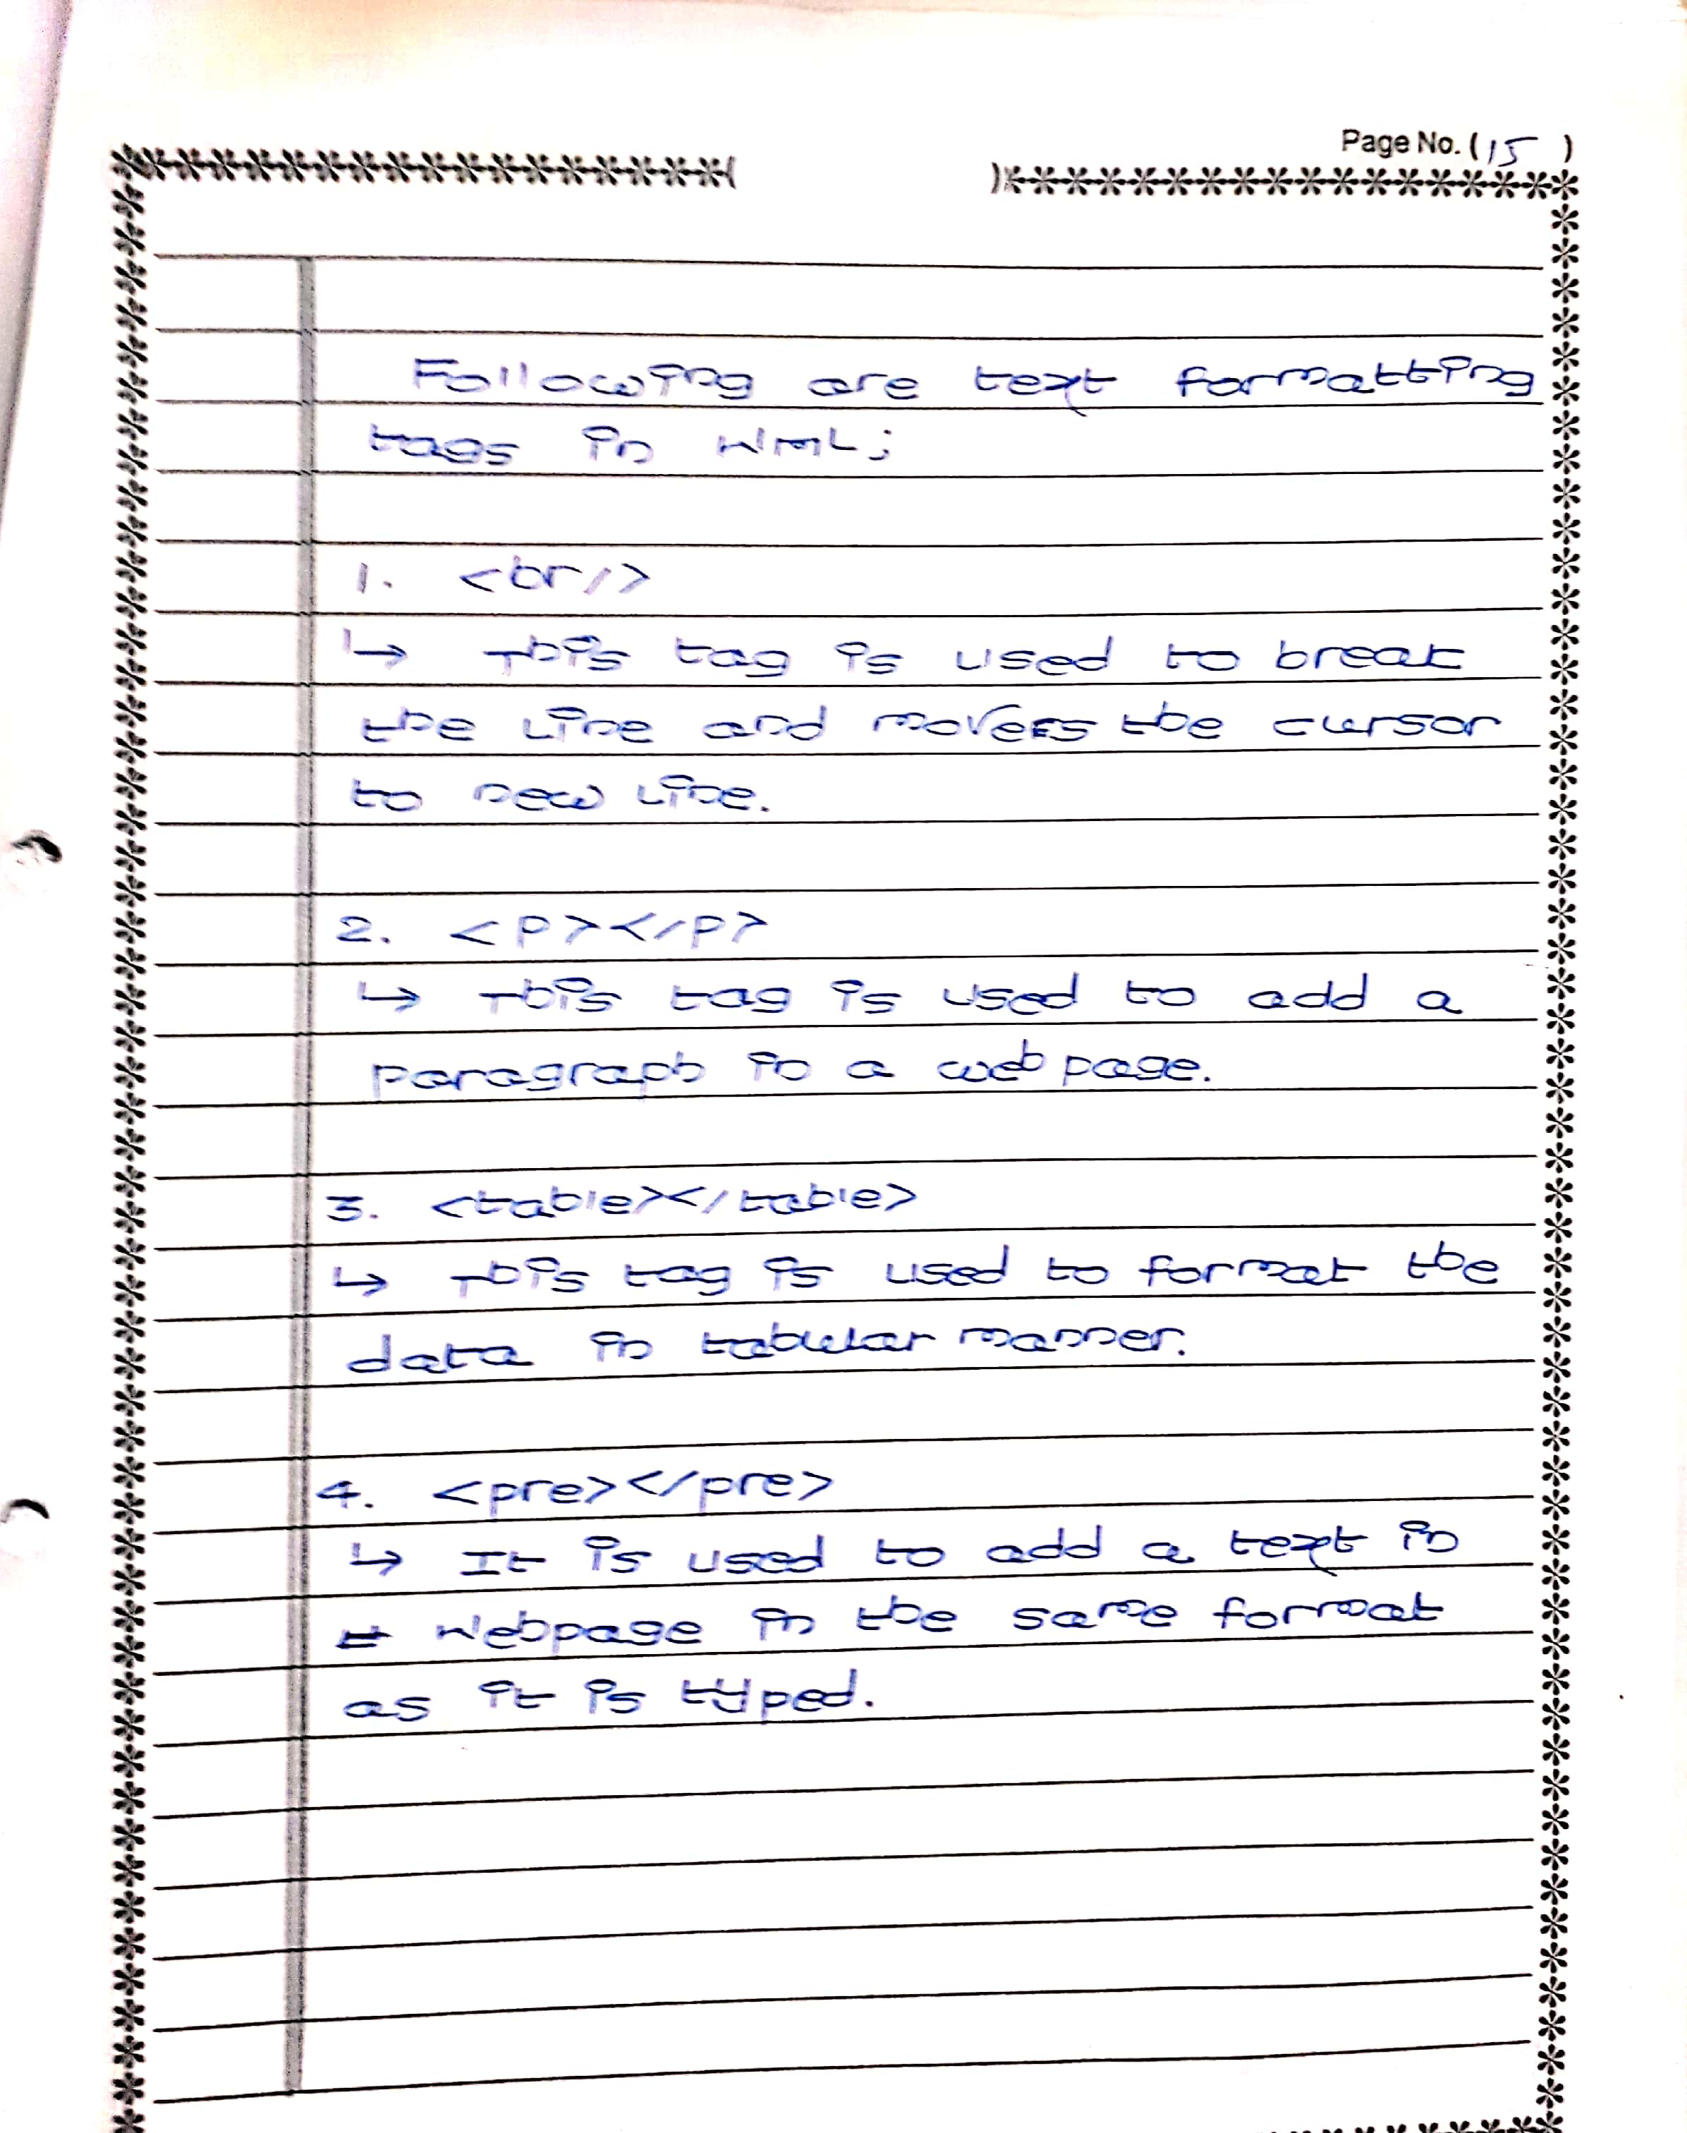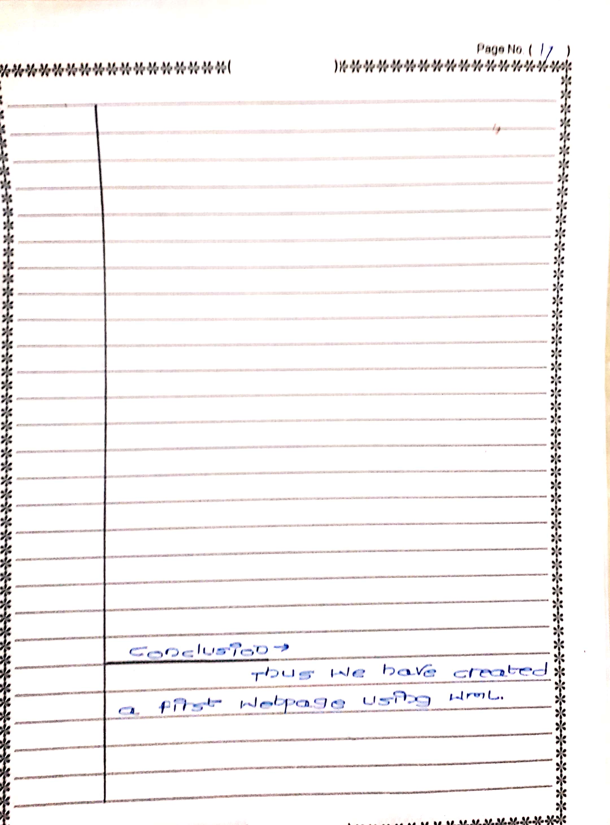

**Name: Furkhan Shaikh**

**Class: BECSEII**

**Aim: Write a program for writing and formatting of text in WML.**

**CODE:**

<?xml version="1.0"?>

<!DOCTYPE wml PUBLIC "-//WAPFORUM//DTD WML 1.1//EN"

"http://www.wapforum.org/DTD/wml_1.1.xml">

<wml>

<card title="Formatting">

<p>

<em>An old man lived in the village</em>. <strong>He was one of the most </strong>unfortunate people in the world. The whole village was tired of him; he was always gloomy, he constantly complained and was always in a bad mood.

<b>The longer </b>he lived, <i>the more </i>bile he was <u>becoming and </u>the more poisonous were his words. People avoided him, because his misfortune became contagious. It was even unnatural and insulting to be happy next to him.

<big>He created</big> the feeling <small>of unhappiness in </small>others

<br>

<br>

<pre> Following Tags are used</pre>

<em>1.em</em><br/>

<strong>2.Strong</strong><br/>

<b>3. Bold(b) </b><br/>

<i>4. Italic(i)</i><br/>

<u>5. Underlined(u)</u><br/>

<big>6. Big(big)</big><br/>

<small>7. Small text</small>

</p>

</card>

</wml>

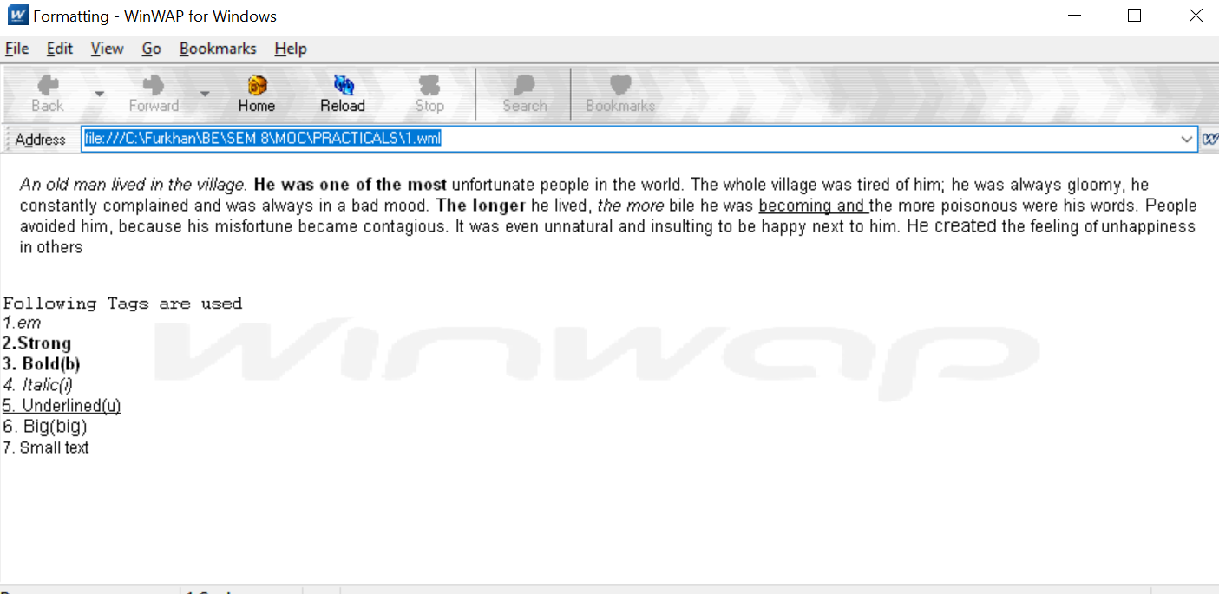

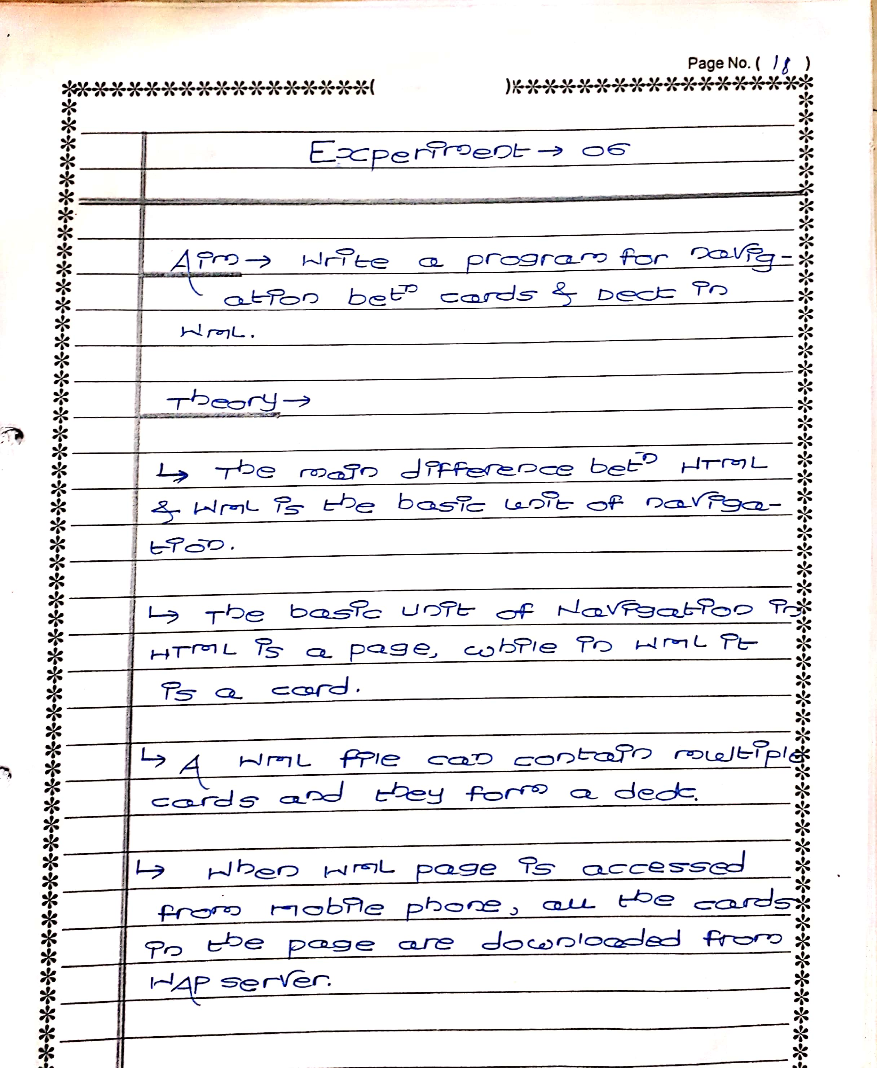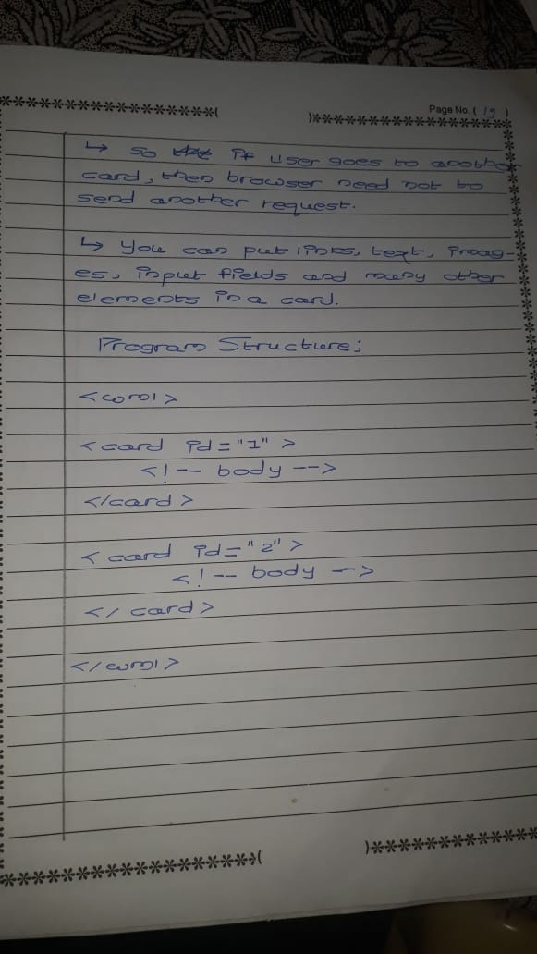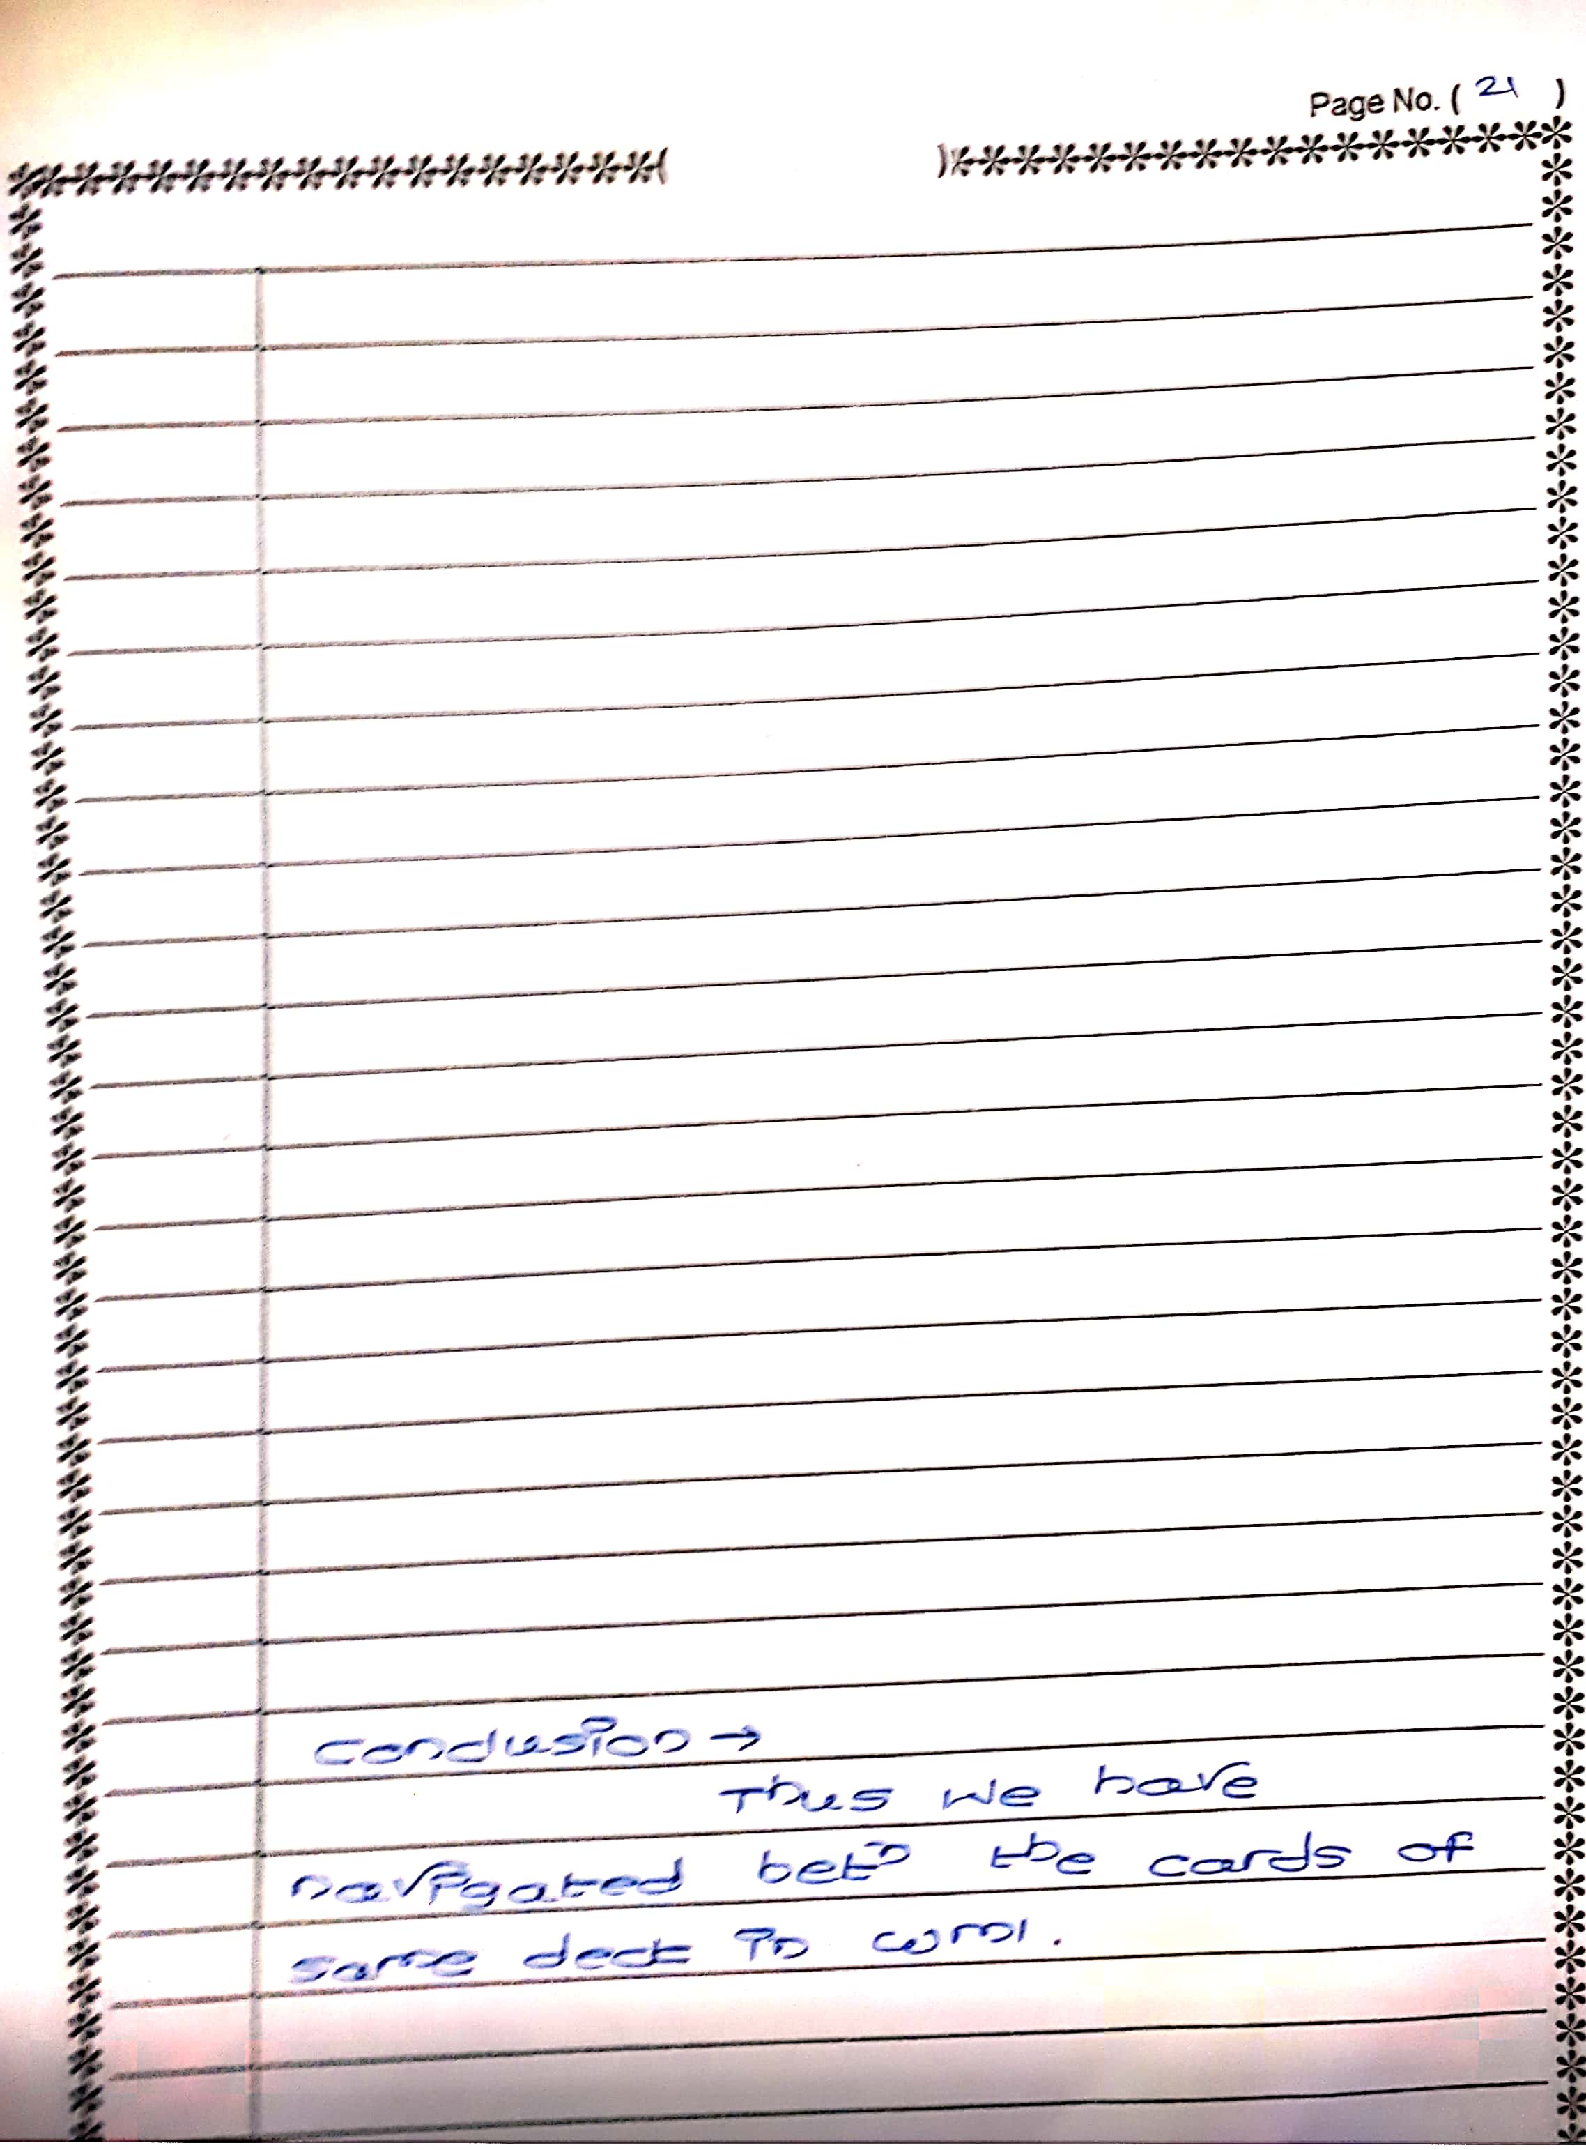

**NAME: FURKHAN MUJIBODDEN SHAIKH**

**CLASS: BECSEII**

**ROLL: 63**

**AIM: WRITE A PROGRAM FOR NAVIGATION BETWEEN CARDS AND DECK IN WML.**

**CODE:**

<wml>

<template>

<do type="accept" label="Pick">

<prev/>

</do>

</template>

<card id="card1">

<do type="accept" label="Black">

<go href="#card2"/>

</do>

<do type="options" label="White">

<go href="#card3"/>

</do>

<p>

Pick a color:

</p>

</card>

<card id="card2">

<p>

You picked black.

</p>

</card>

<card id="card3">

<p>

You picked white.

</p>

</card>

</wml>

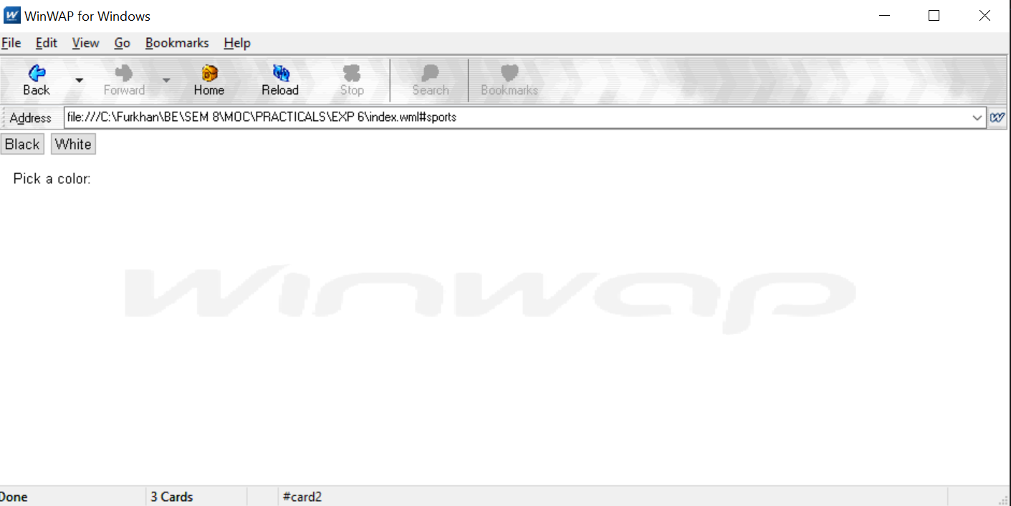

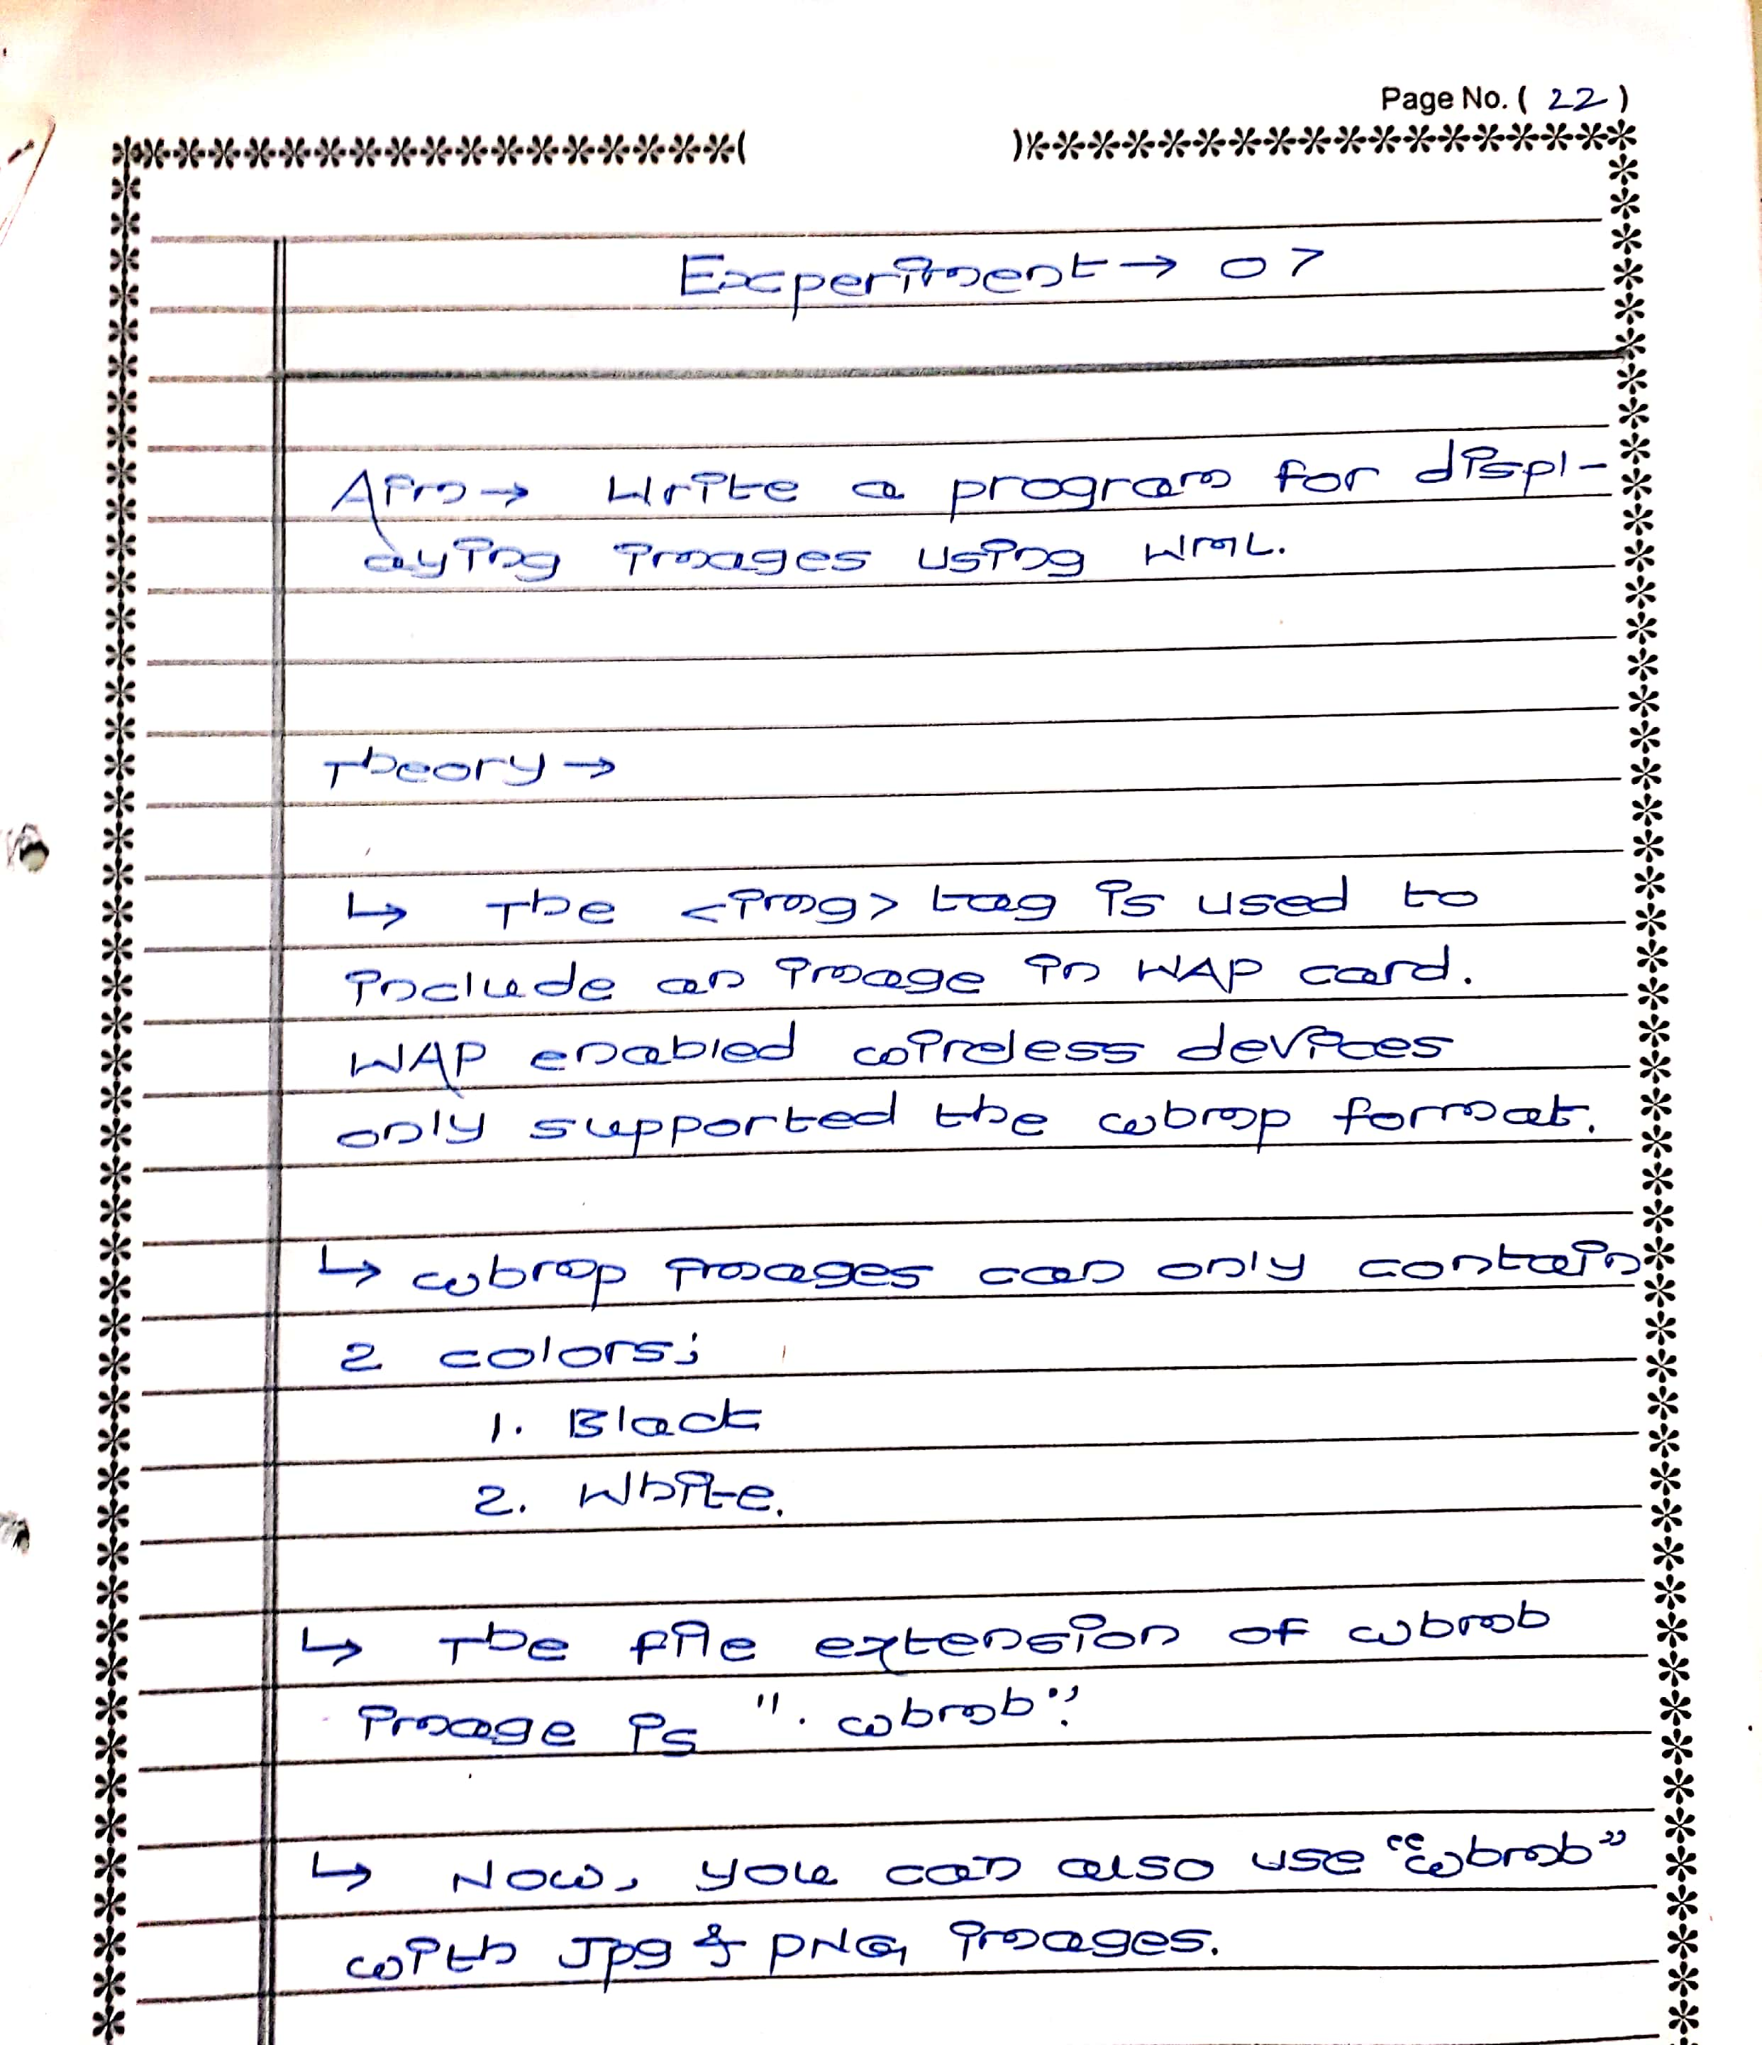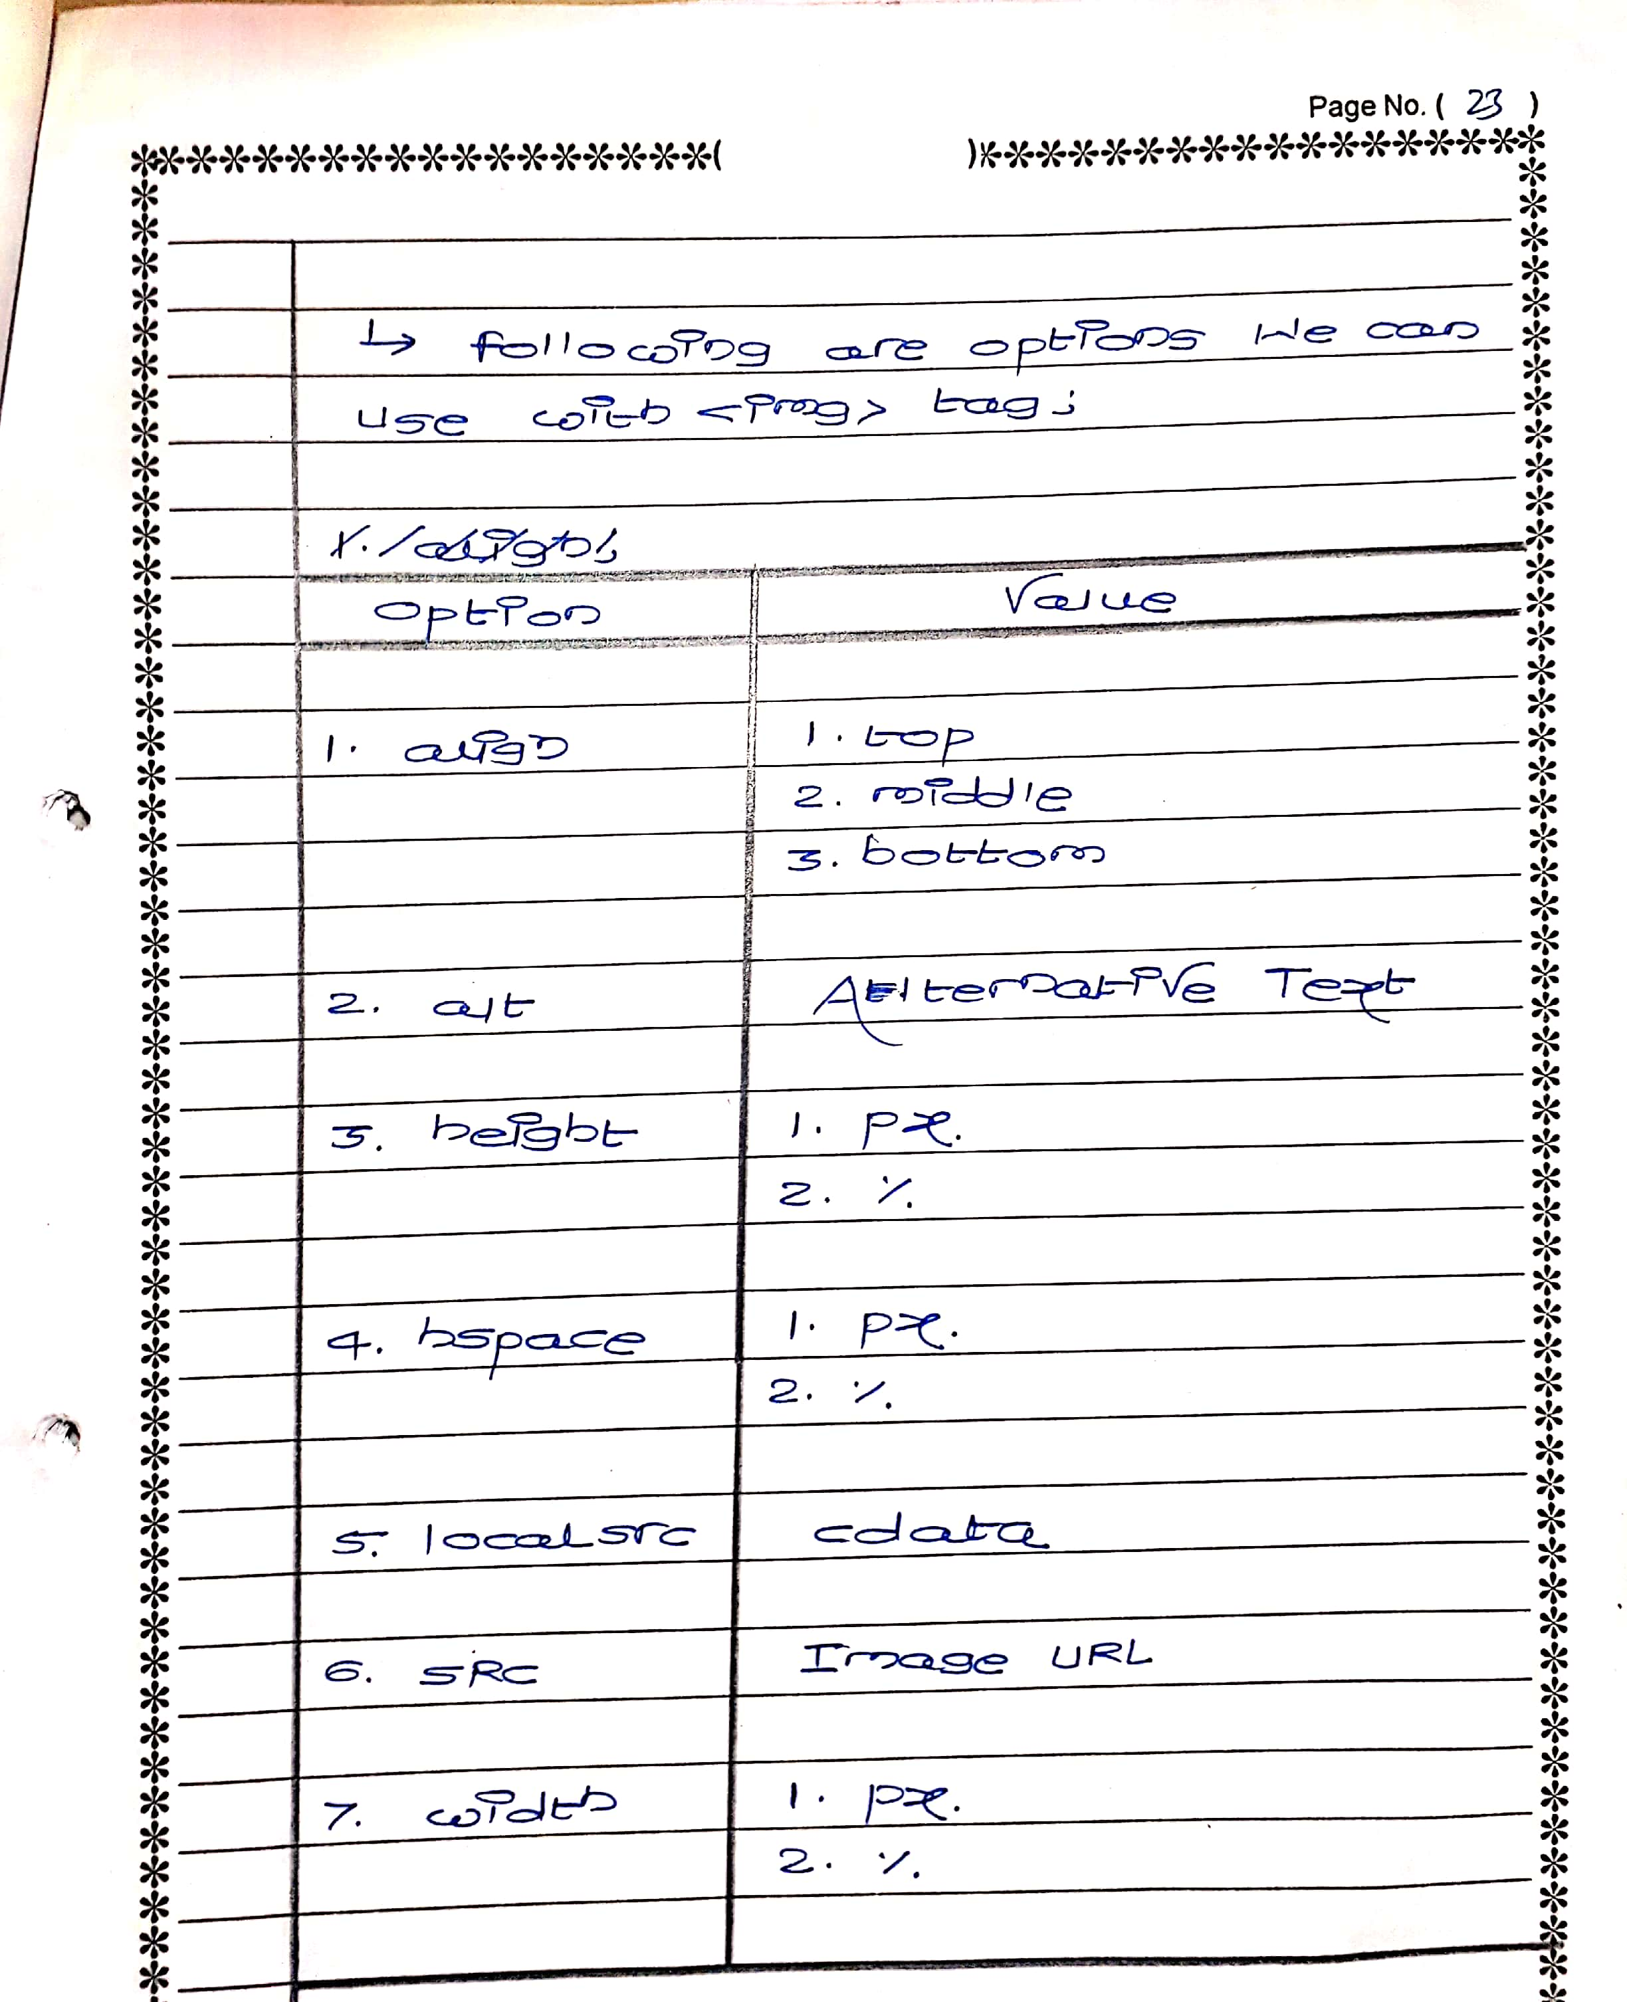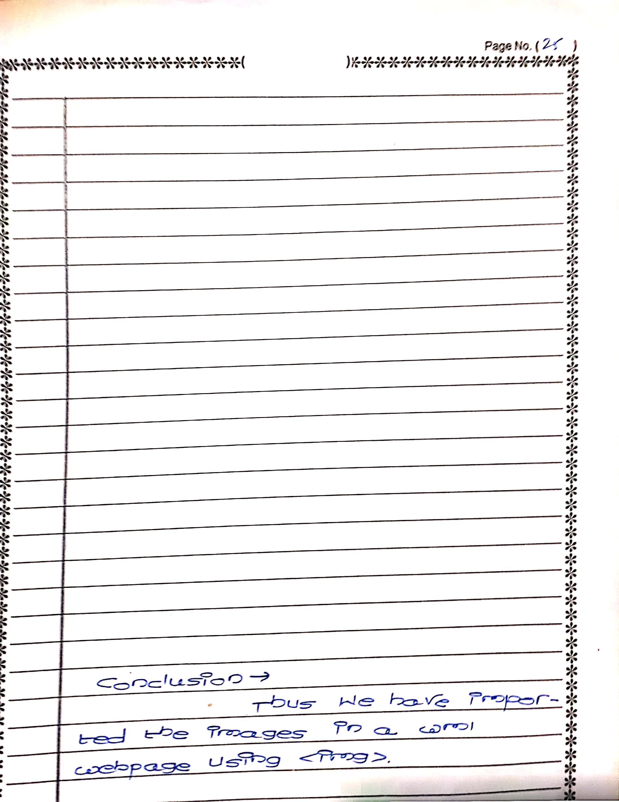

**NAME: FURKHAN MUJIBODDEN SHAIKH**

**CLASS: BECSEII**

**ROLL: 63**

**AIM: WRITE A PROGRAM FOR DISPLAYING OF IMAGE USING WML.**

**CODE:**

**<wml>**

**<card id="card1" title="Image in WML">**

**<p>**

**<img src="thor.jfif" align="center" alt="Smile" height="200" width="200" /><br/>**

**<br>**

**<br>**

**<big>HE IS GOD OF THUNDER.</big>**

**</p>**

**<p>**

**<img src="iron.jpg" alt="Smile" height="200" width="200" /><br/>**

**<br>**

**<br>**

**<big>HE IS GOD OF AVENGERS.</big>**

**</p>**

**</card>**

**</wml>**

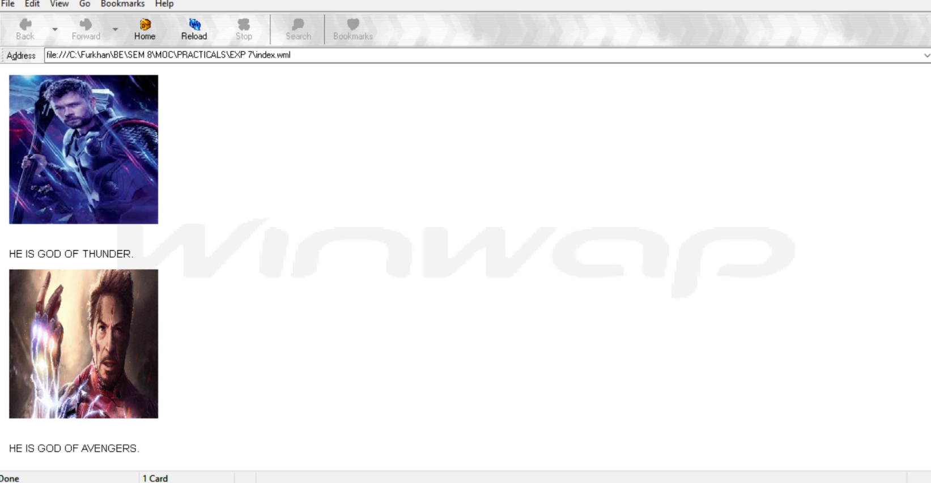

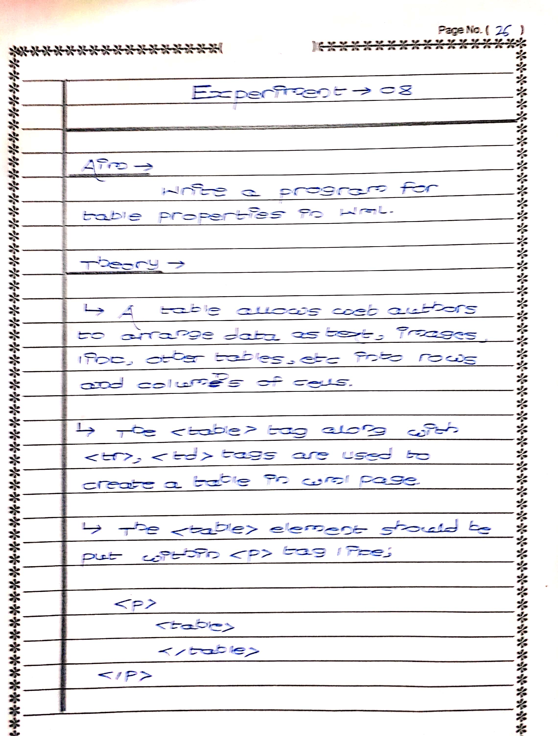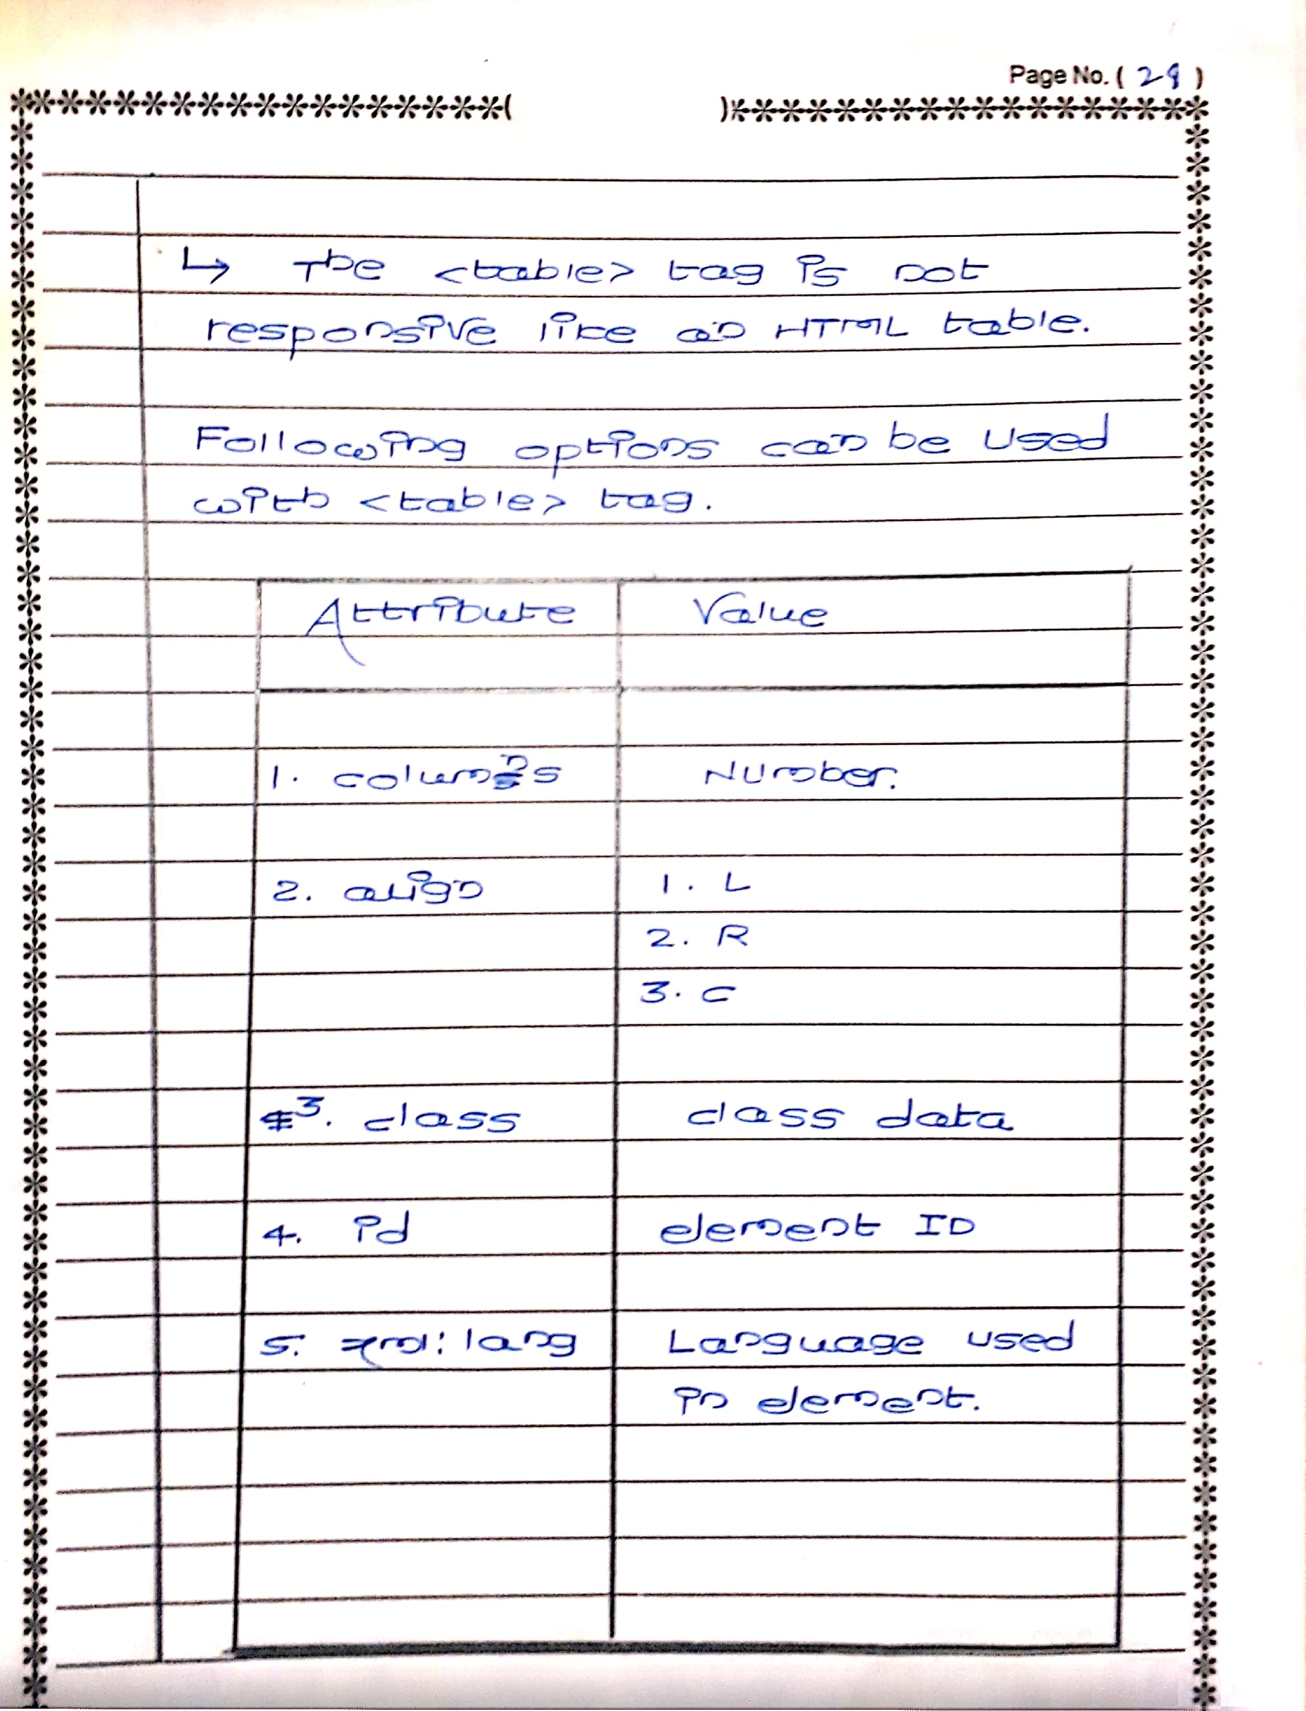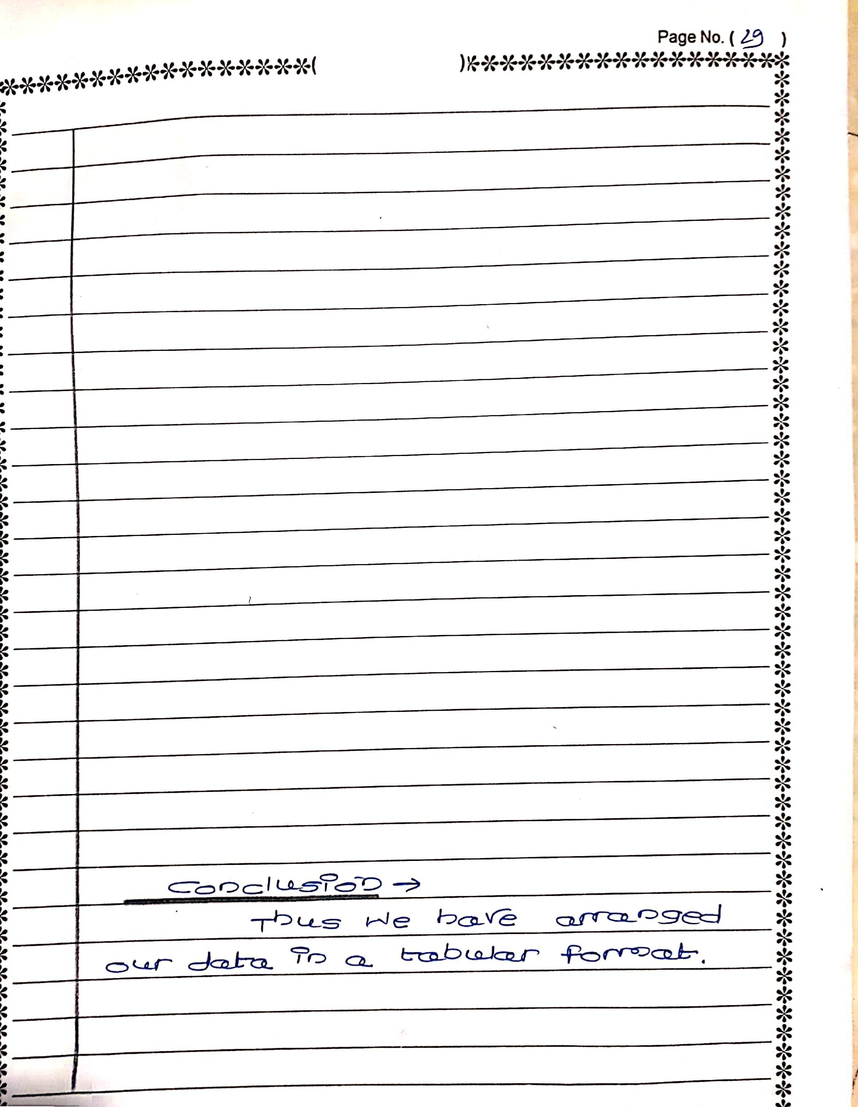

**NAME: FURKHAN MUJIBODDEN SHAIKH**

**CLASS: BECSEII**

**ROLL: 63**

**AIM: WRITE A PROGRAM FOR TABLE PROPERTIES OF WML**

CODE:

<wml>

<card title="WML Tables">

<p>

<table columns="3" align="LCR">

<tr>

<td>NAME</td>

<td>CLASS</td>

<td>ROLL</td>

</tr>

<tr>

<td>FURKHAN MUJIB SHAIKH</td>

<td>BECSEII</td>

<td>63</td>

</tr>

<tr>

<td>PRASHANT MANOJ PHULARI</td>

<td>BECSEII</td>

<td>51</td>

</tr>

<tr>

<td>SANTOSH VINAYAK SURYAWANSHI</td>

<td>BECSEII</td>

<td>71</td>

</tr>

<tr>

<td>MAYURESH GAJANAN POPHALE</td>

<td>BECSEII</td>

<td>52</td>

</tr>

<tr>

<td>ANUJA TEHRA</td>

<td>BECSEII</td>

<td>72</td>

</tr>

<tr>

<td>RUPALI BHANGE</td>

<td>BECSEII</td>

<td>05</td>

</tr>

<tr>

<td>PRIYANKA JADHAV</td>

<td>BECSEII</td>

<td>79</td>

</tr>

</table>

</p>

</card>

</wml>

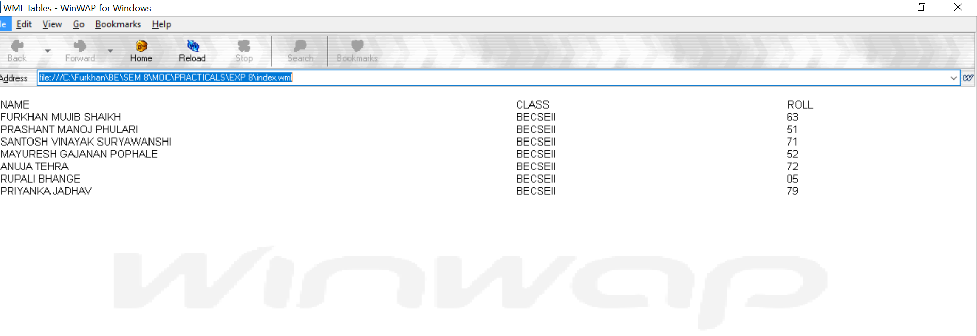

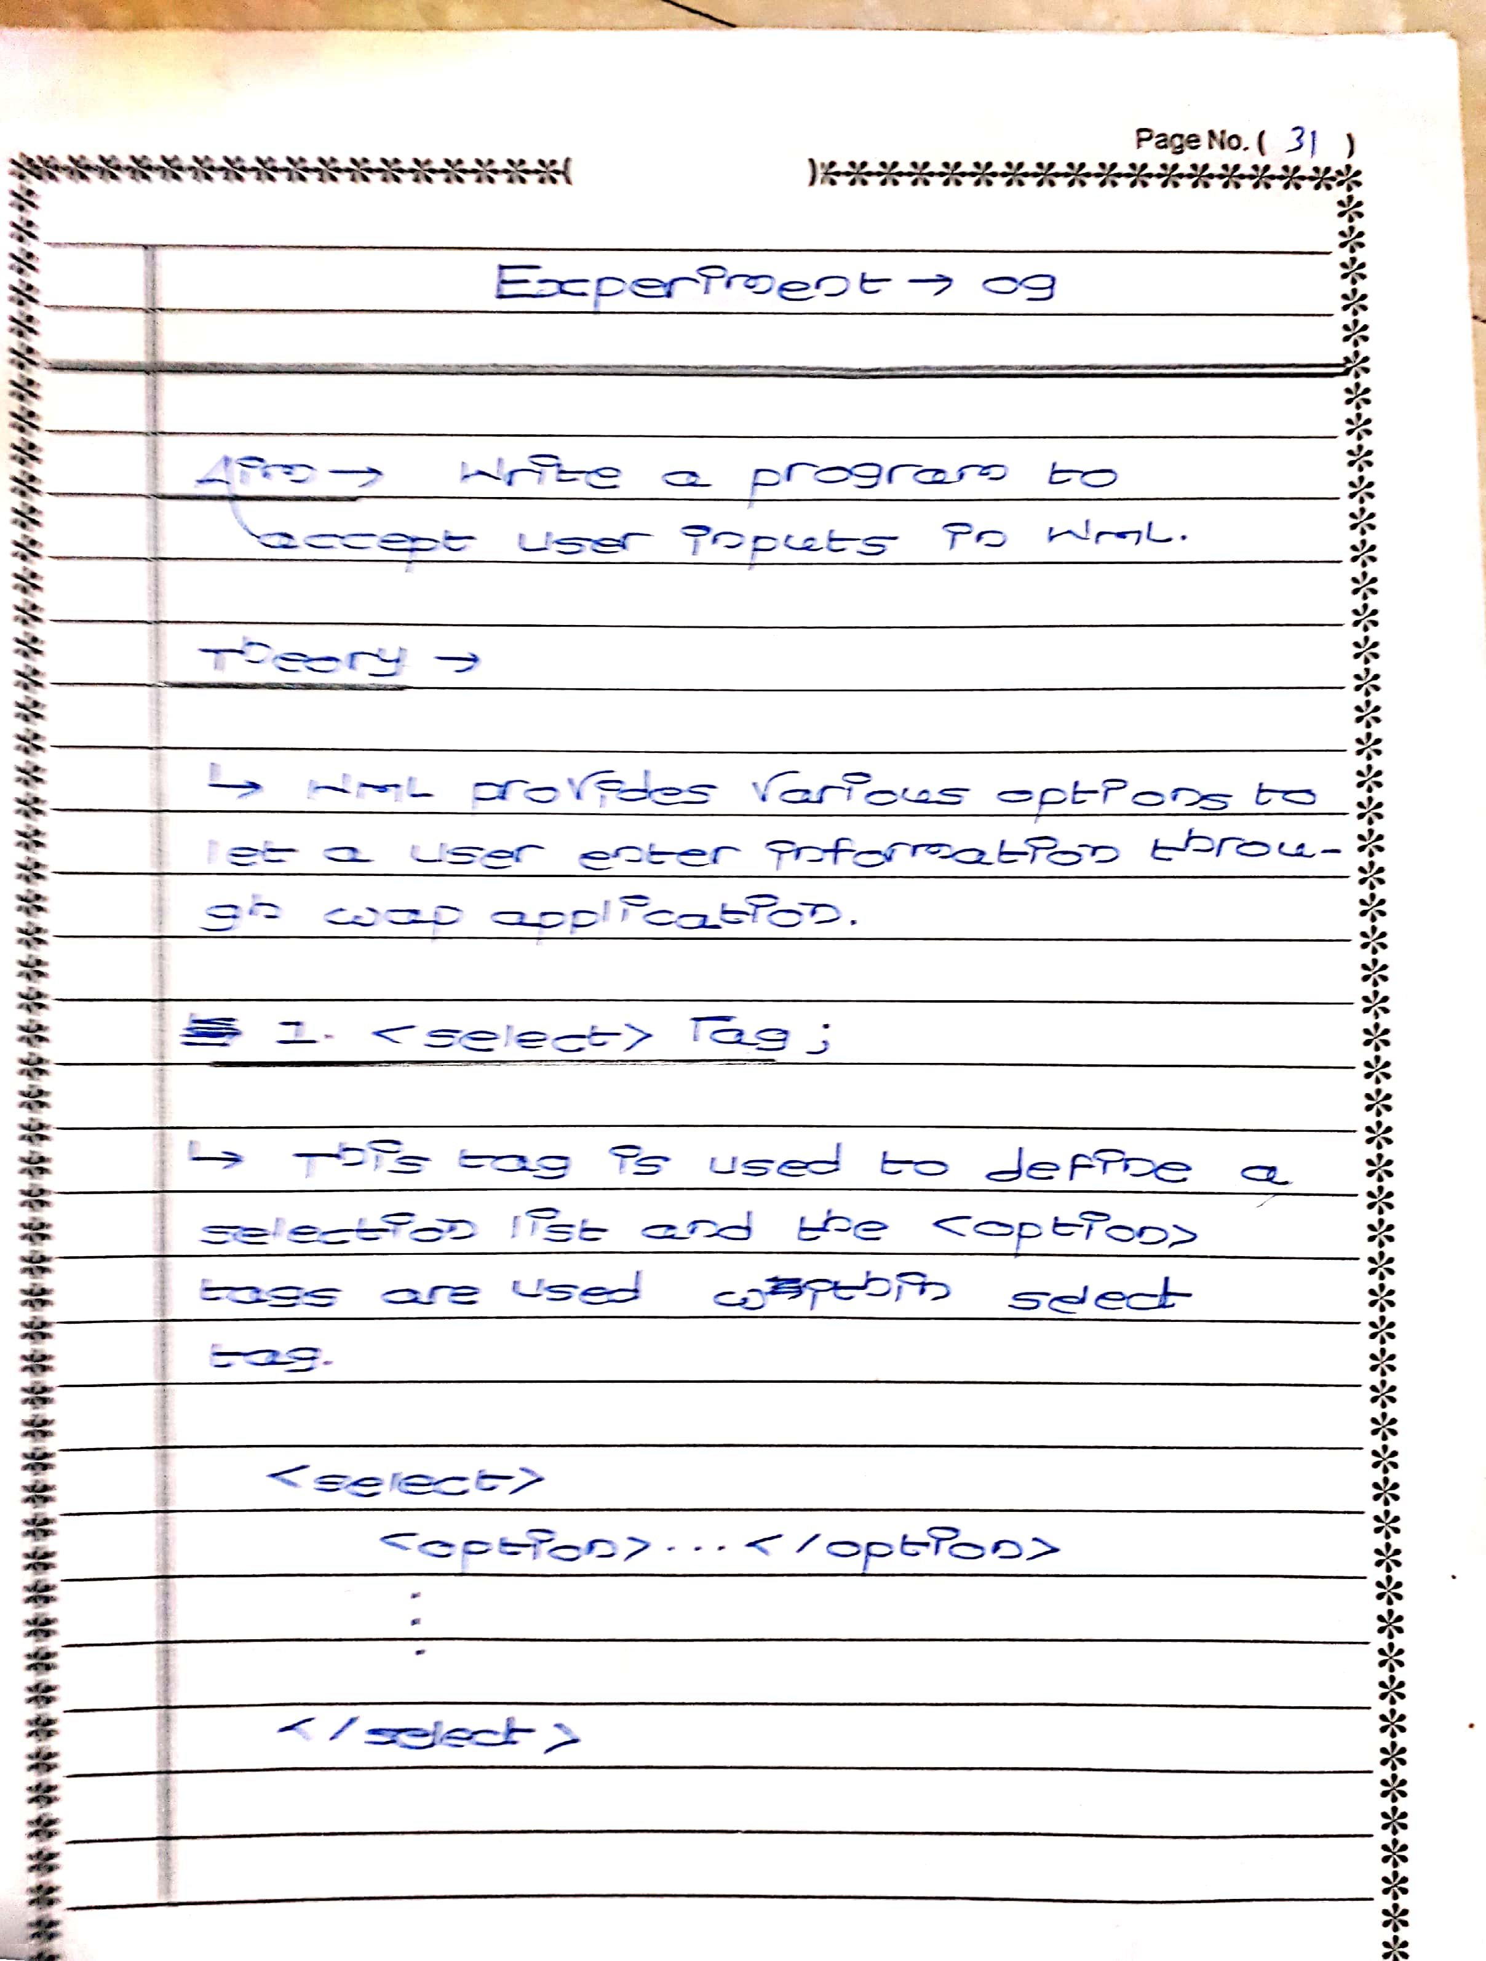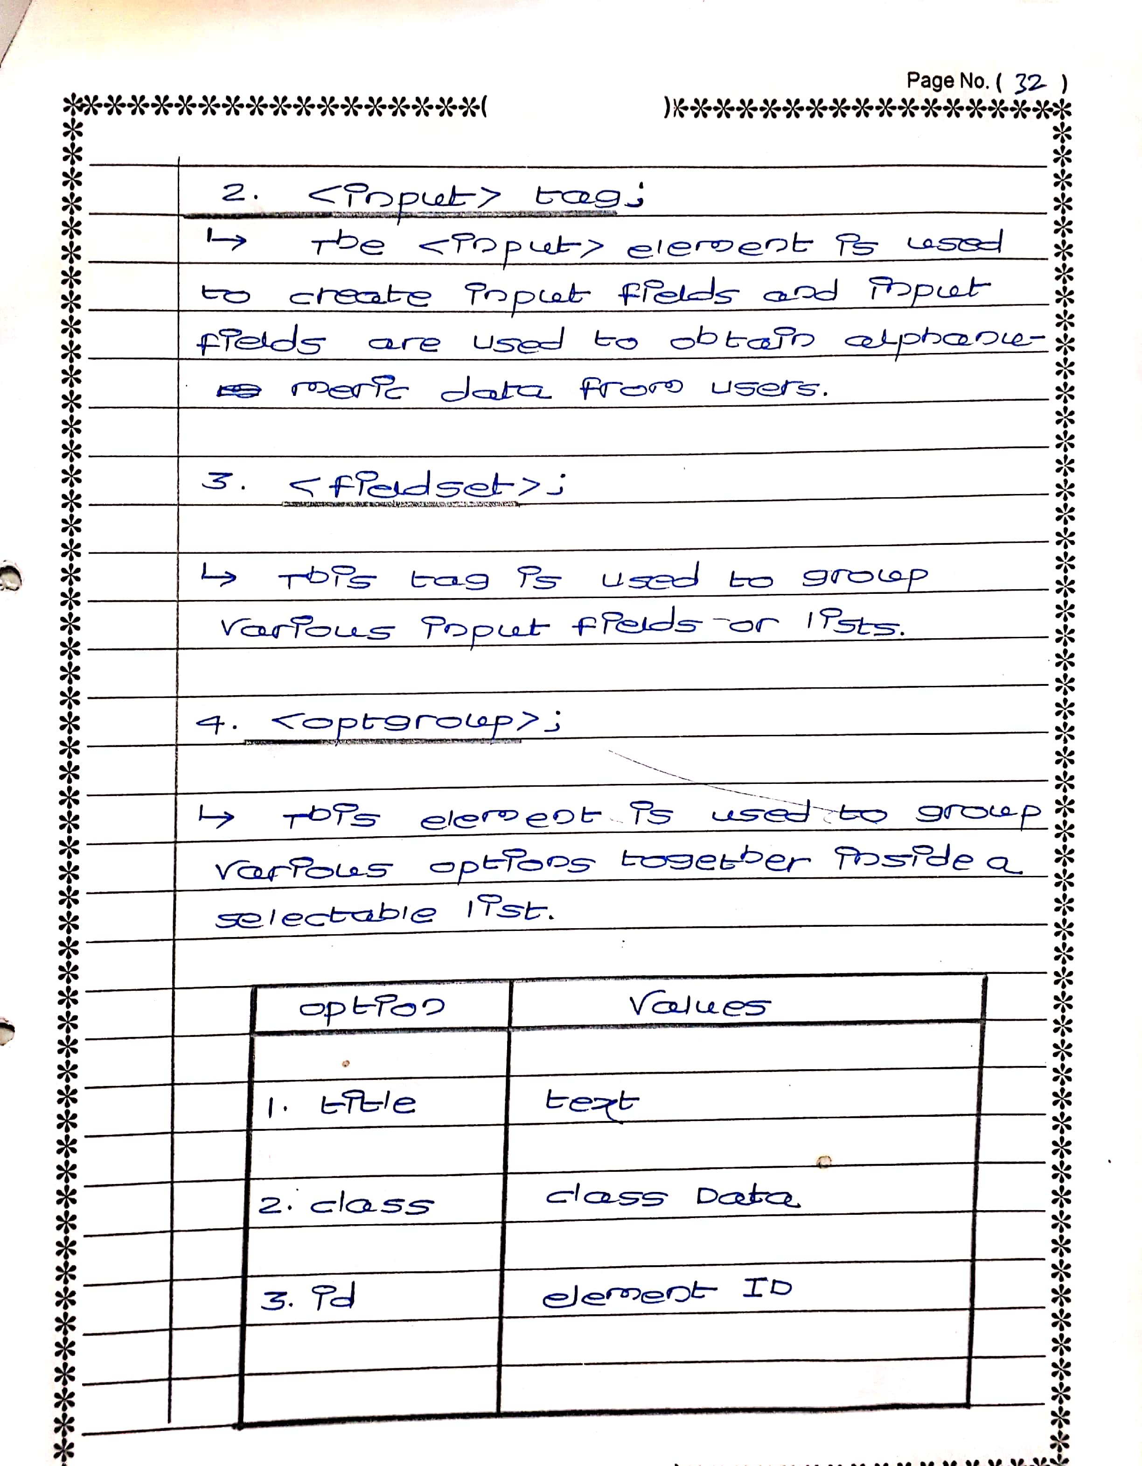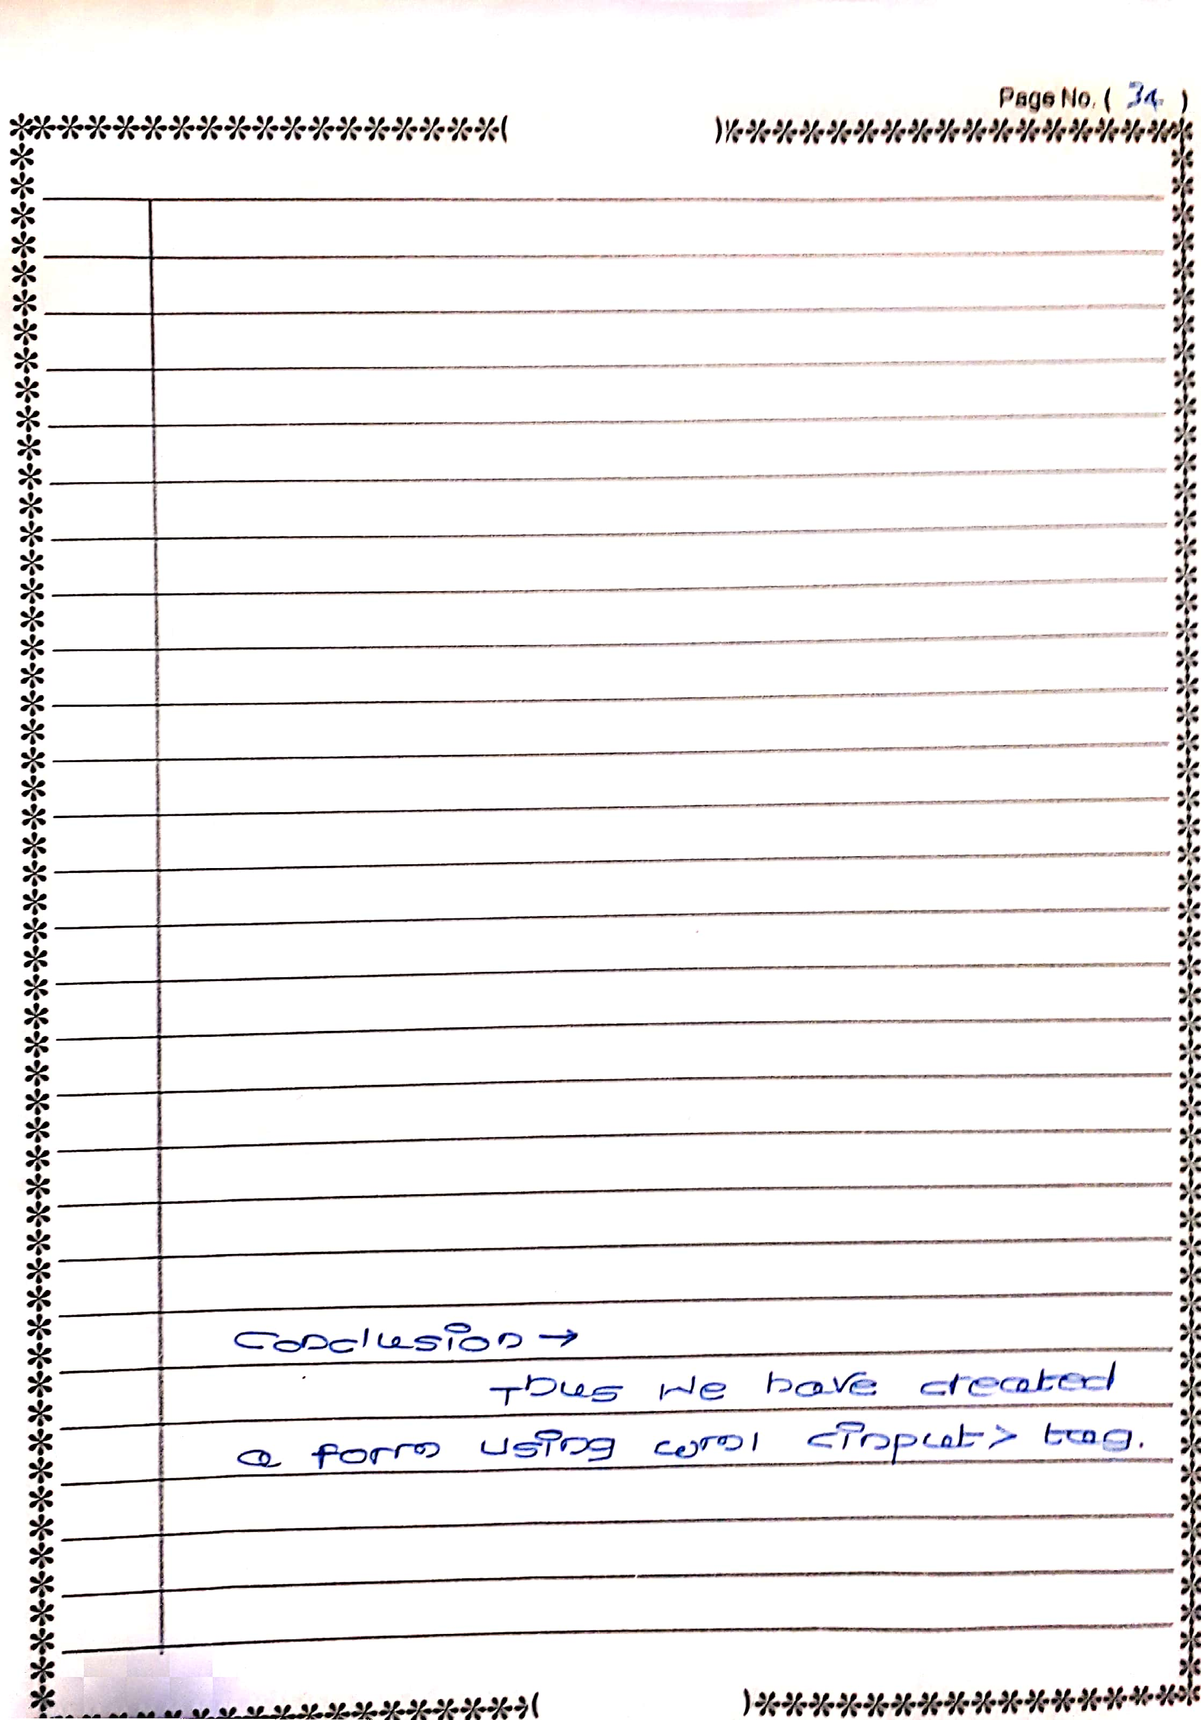

**NAME: FURKHAN MUJIBODDEN SHAIKH**

**CLASS: BECSEII**

**ROLL: 63**

**AIM: WRITE A PROGRAM FOR TABLE PROPERTIES OF WML**

<wml>

<card title="Selectable List">

<p> Select Your Class :

<select>

<option value="BECSEII">BECSEII</option>

<option value="BECSEI">BECSEI</option>

</select>

<br><br>

First Name:<br>

<input name="name" size="12"/>

<br>

<br>

Age : <br>

<input name="age" size="12" format="*N"/>

<br>

<br>

Roll :<br>

<input name="roll" size="12" format="*N"/>

<anchor>

<go method="get" href="process.php">

<postfield name="name" value="$(name)"/>

<postfield name="age" value="$(age)"/>

<postfield name="roll" value="$(roll)"/>

</go>

<br><br>

Submit Data

</anchor>

</p>

</card>

</wml>

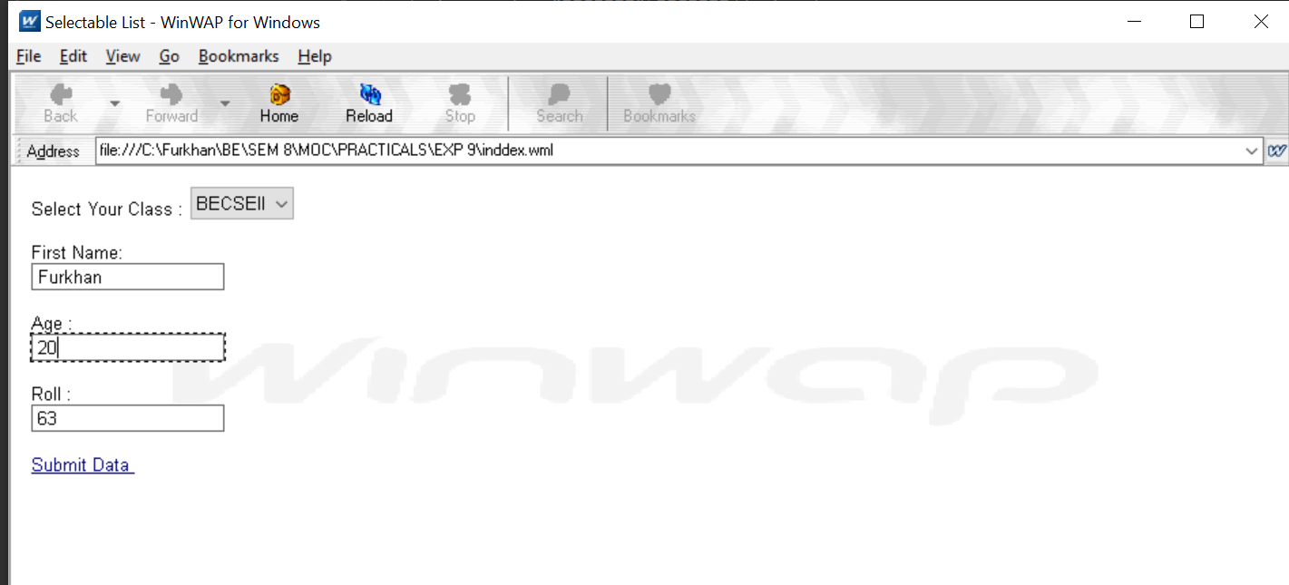

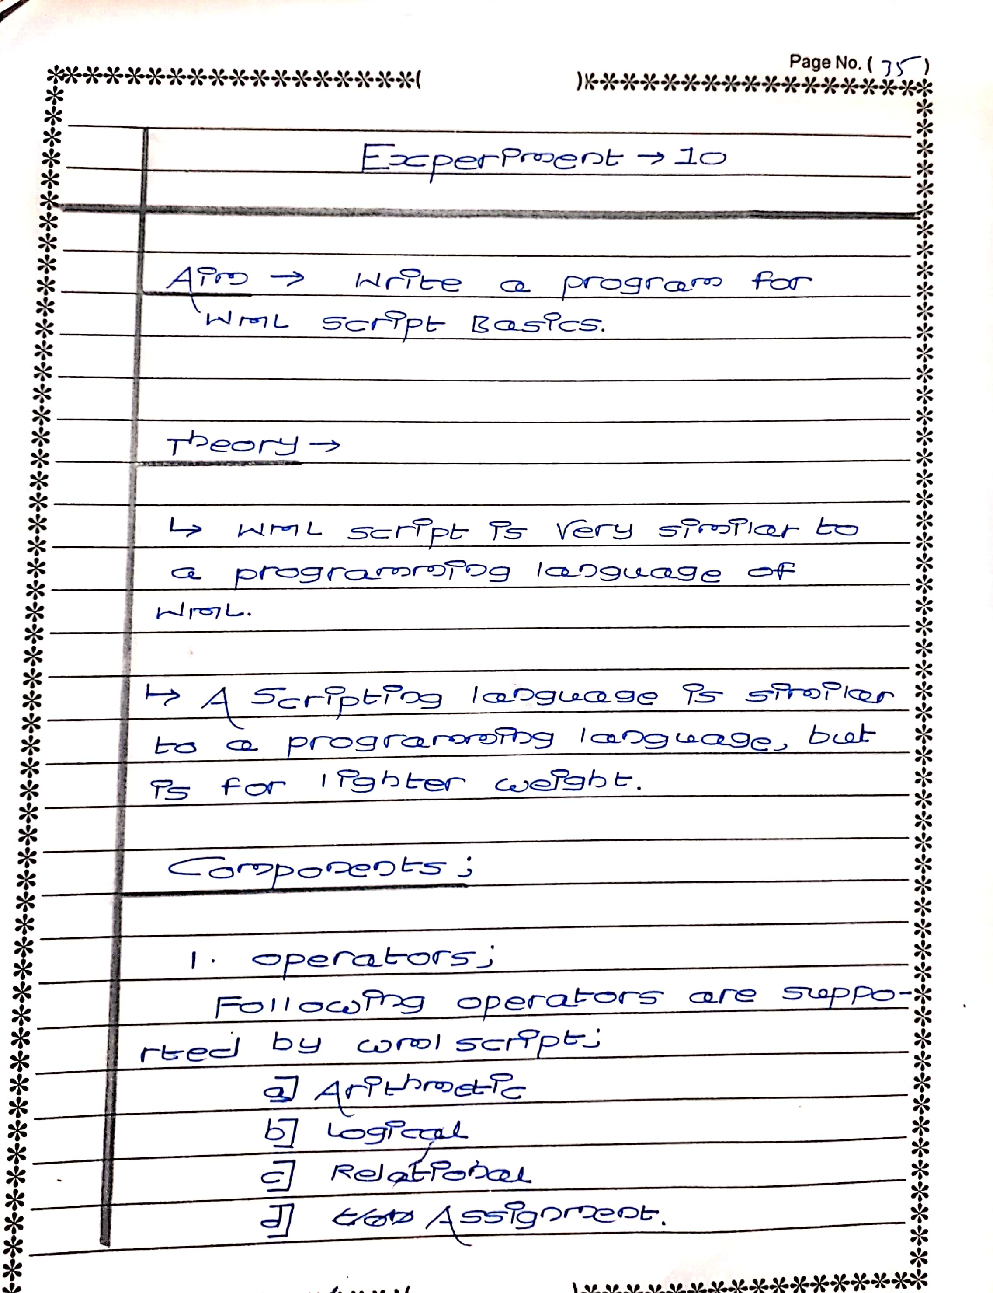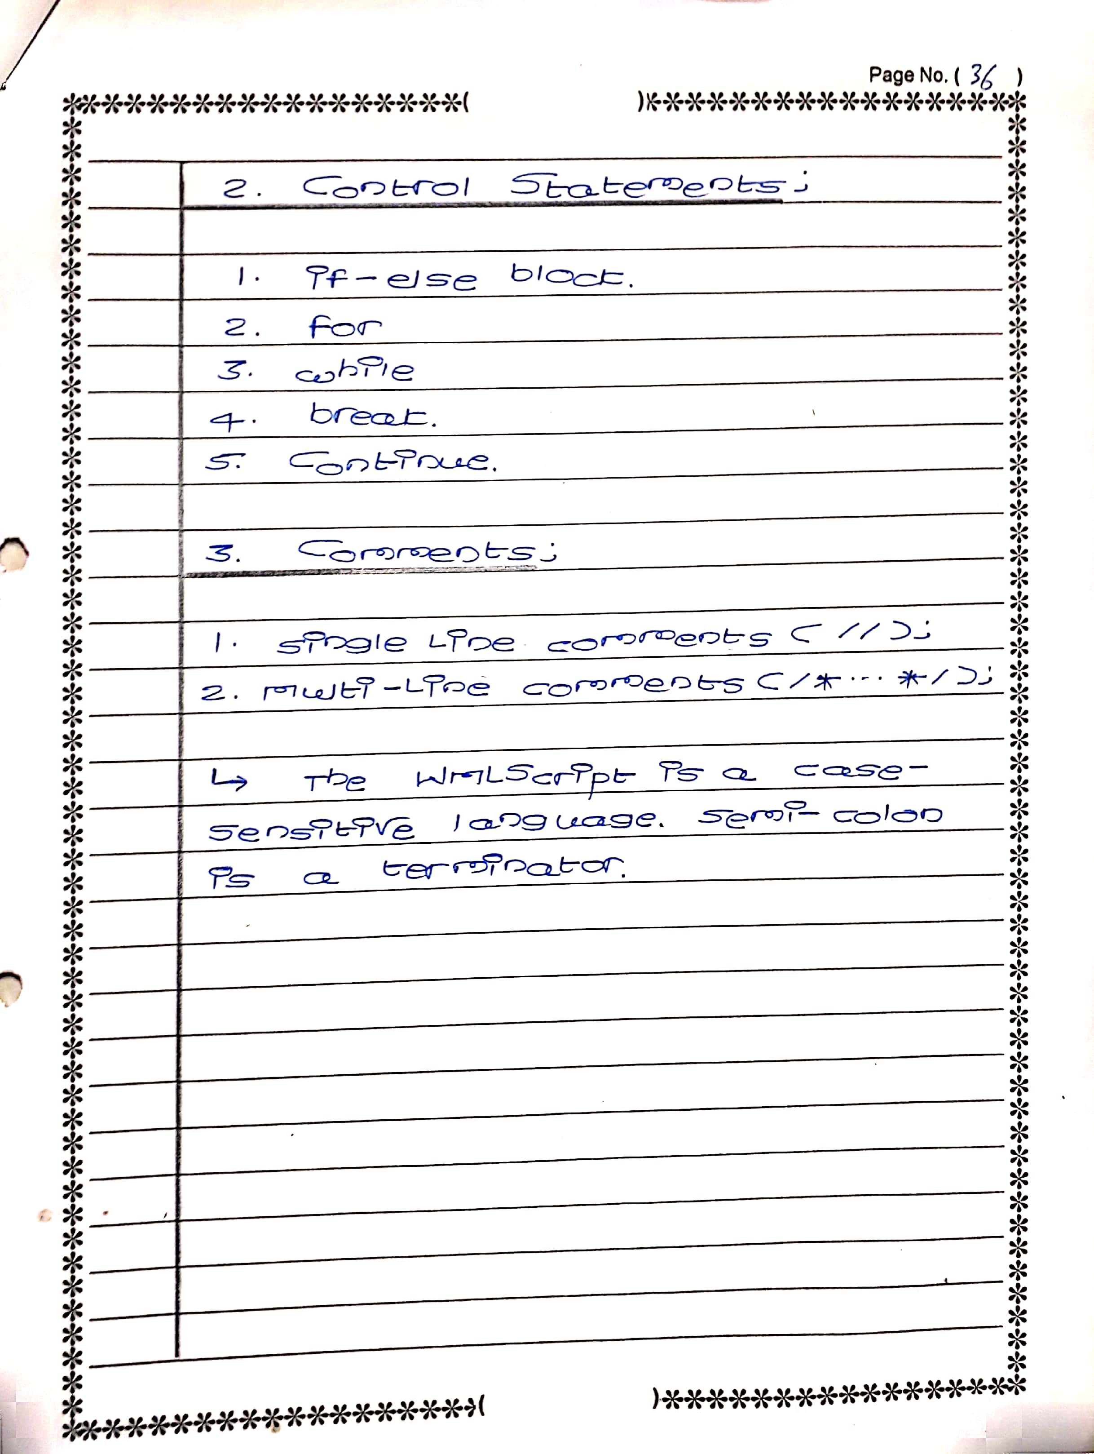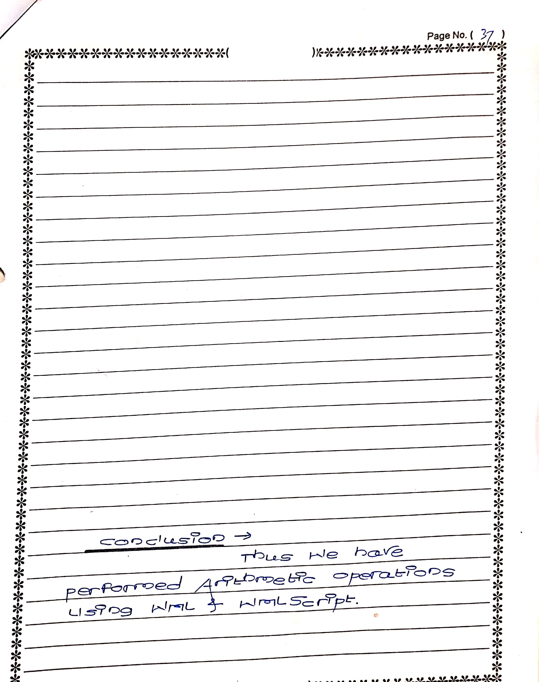

**NAME: FURKHAN MUJIBODDEN SHAIKH**

**CLASS: BECSEII**

**ROLL: 63**

**AIM: WRITE A PROGRAM FOR TABLE PROPERTIES OF WML**

**INDEX.WML:**

<wml>

<card id="card1" title="prompt() Example">

<p>

ENTER VALUE OF A:

<br>

<input name="A" size="12" />

<br><br>

ENTER VALUE OF B:

<br>

<input name="B" size="12" />

<br><br>

<a href="index.wmls#add($(A),$(B))">Click Here To Execute Script</a><br/>

$(add)

</p>

</card>

</wml>

**INDEX.WMLS**

extern function add(A,B)

{

WMLBrowser.setVar("add"," Concatenation: " + A+B);

WMLBrowser.refresh();

}

